**Task on IAM**

**Introduction to AWS IAM (Identity and Access Management)**

AWS **Identity and Access Management (IAM)** is a critical service that allows users to securely manage **permissions and access control** in their AWS environment. IAM ensures that **only authorized individuals or systems** can access AWS resources.

**Key Features of IAM**

1. **User Management** – Create and manage individual IAM users.
2. **Groups & Policies** – Define policies and assign them to groups or users.
3. **Roles** – Allow AWS services or external users to assume temporary permissions.
4. **Fine-Grained Permissions** – Control access to AWS resources with JSON-based policies.
5. **Multi-Factor Authentication (MFA)** – Add an extra layer of security.
6. **Access Keys & Temporary Credentials** – Enable programmatic access through AWS CLI & SDKs.

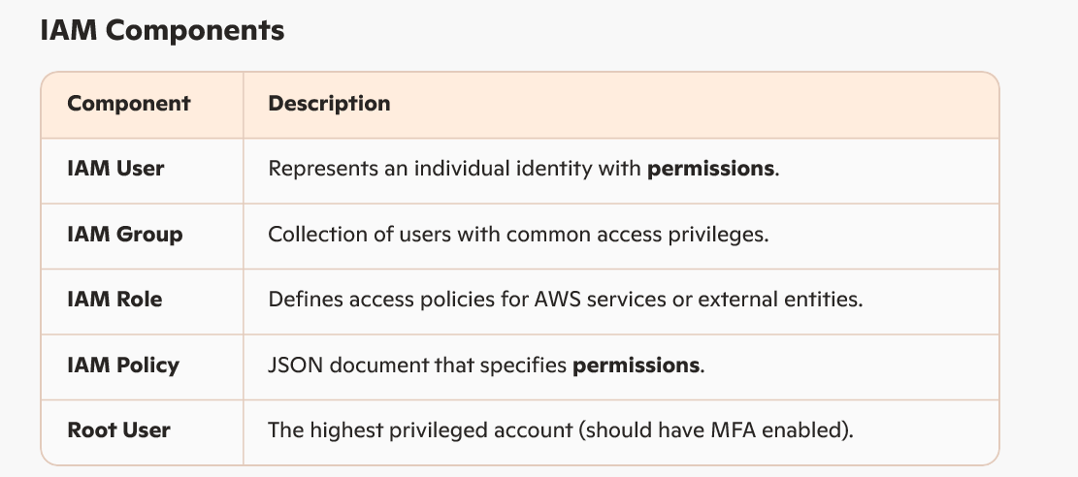

**1) Create one IAM user and assign ec2, S3 full access role.**

Create IAM user

To create IAM user first we need to login to our AWS account using Root user email address and password

Once succesfully logged in Search for IAM in dashboard

Now select the IAM option and search for Users option

Click on Create Users

Specify the User details

User name

Proivude user acces to the AWS Management console

-If you want to give console access select this option

-Or else dont select this option then you can gice AWS CLI access

Now Set Permissions for User

Permissions option

Add user to group

Copy Permissions

Attach Policy details

-Select AWS managed or Customer managed policies

As in the task asked to provide EC2 and S3 full access, select accordigly and provide the attach the policies to the user.

Click on Next

Once you select this Provide access option in Step1 it will give console access to the user and asked to create console password.

Autogenerated Password

Customer password : select this option and create the password

Review and create user

Retrieve the password

Console sign-in details

Copy the URL, username and password

Try log in into another browser with IAM user credentials, you can see the dashboard details that means you have logged in successfully.

Now go To EC2 instance check if there are any API errors are reflecting, if not that means you got the full access for EC2 and try to launch one instance and check the status

Now go to S3, try to create a new bucket with required details and try to access the bucket.

If successful means whatever the permissions that you have given to the IAM user, its configured correctly.

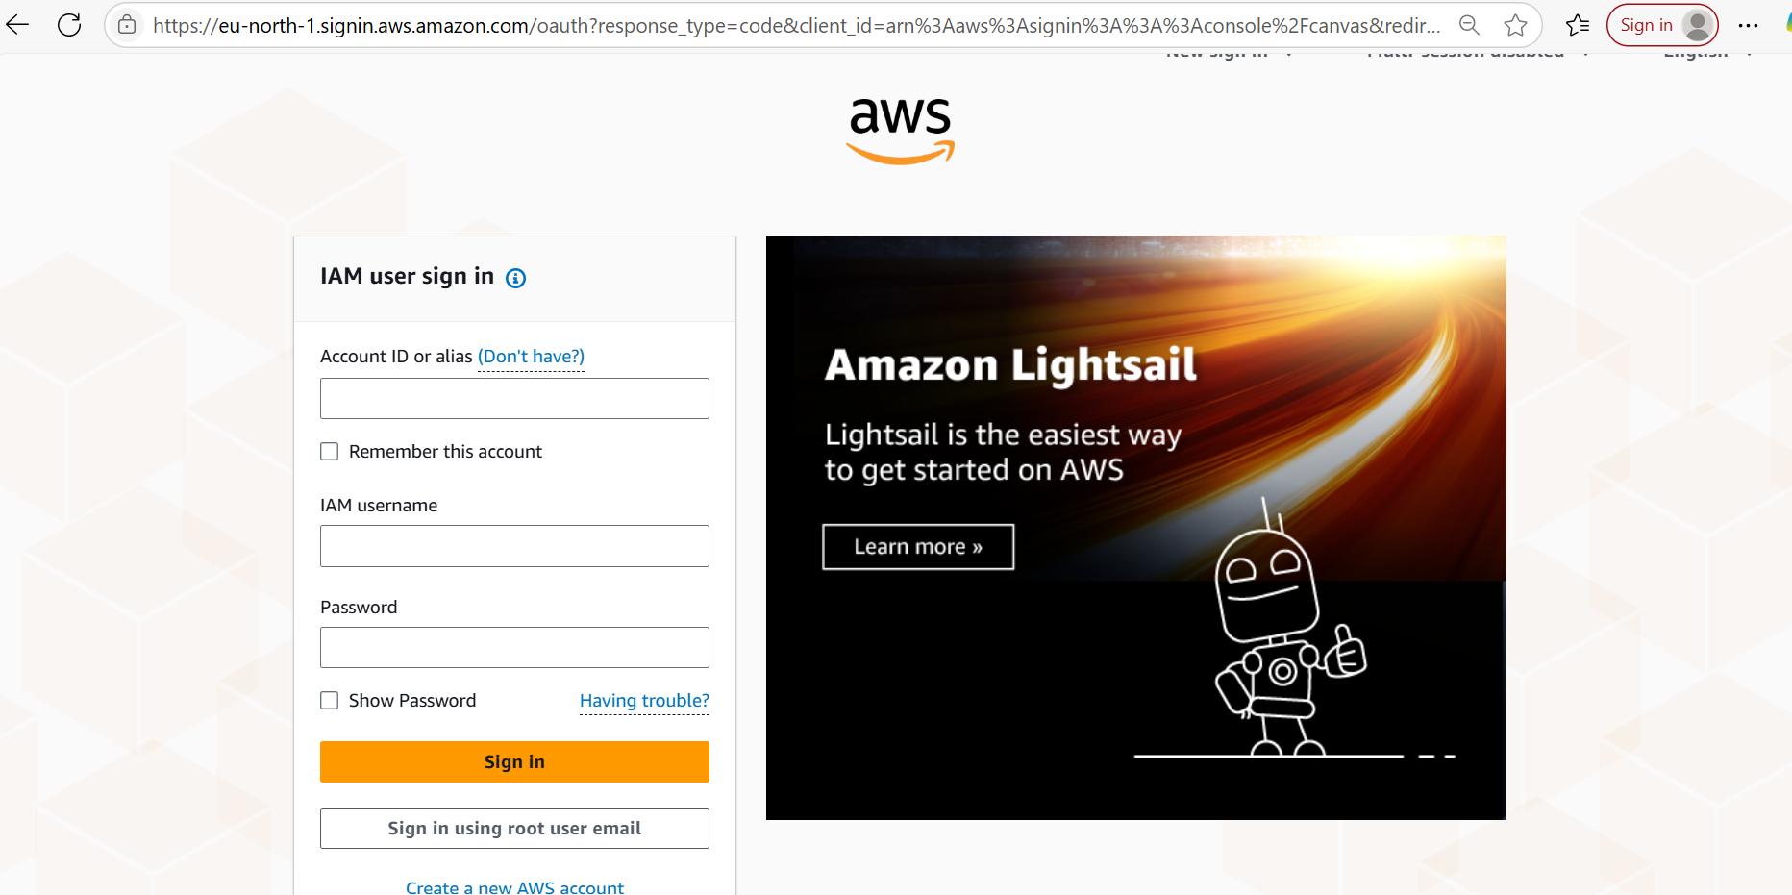

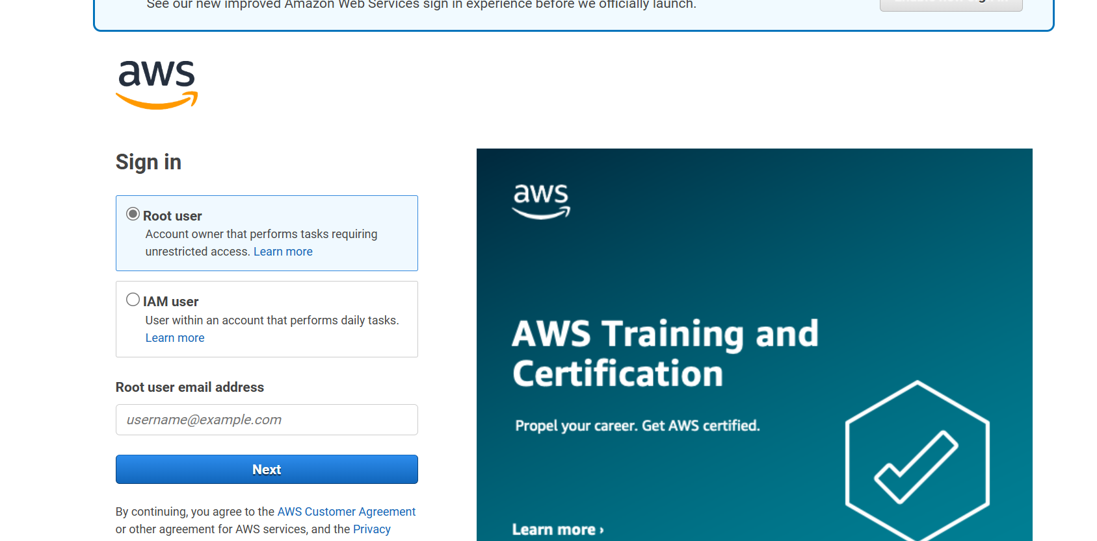

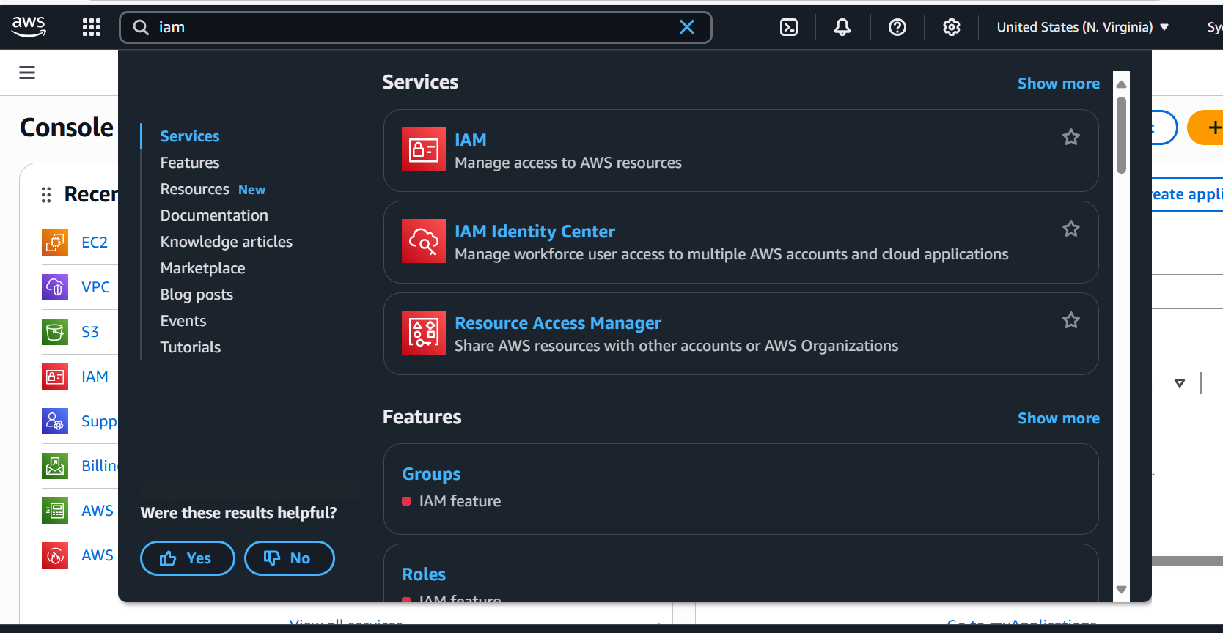

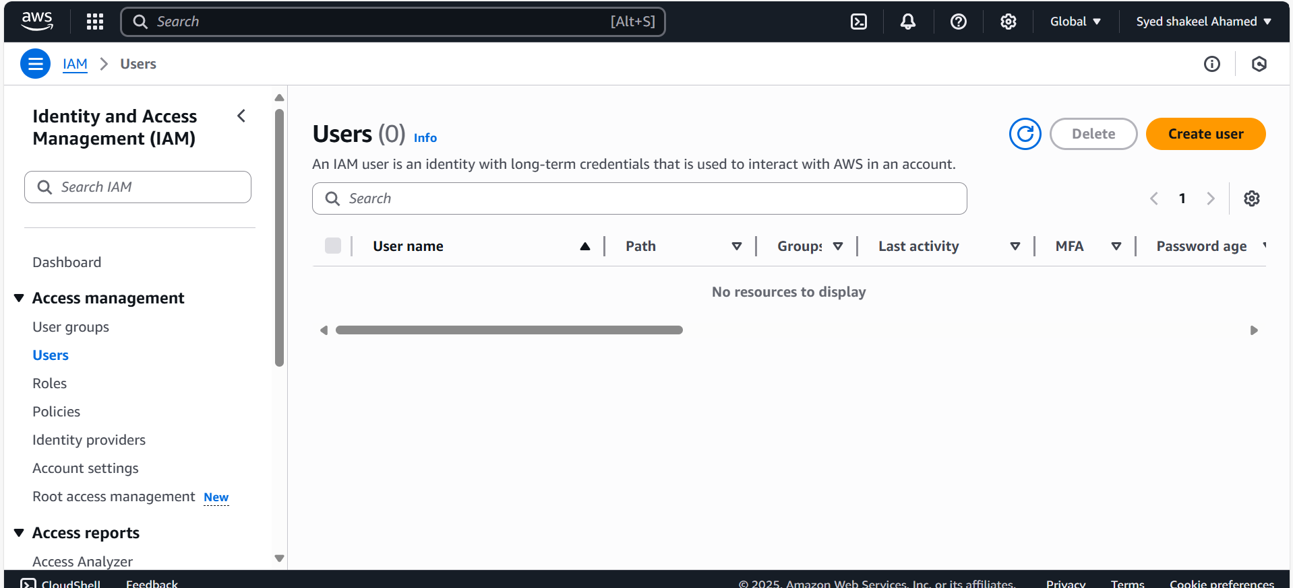

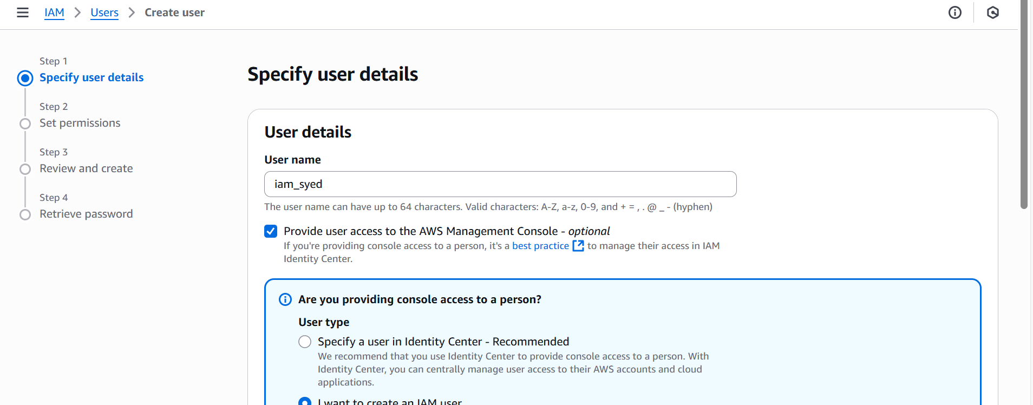

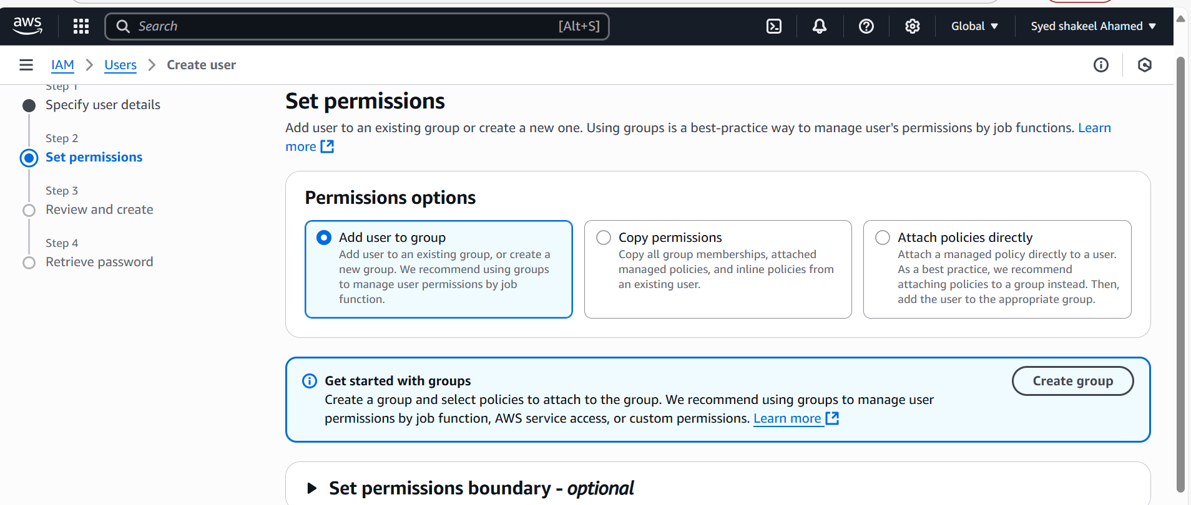

EC2-Full access

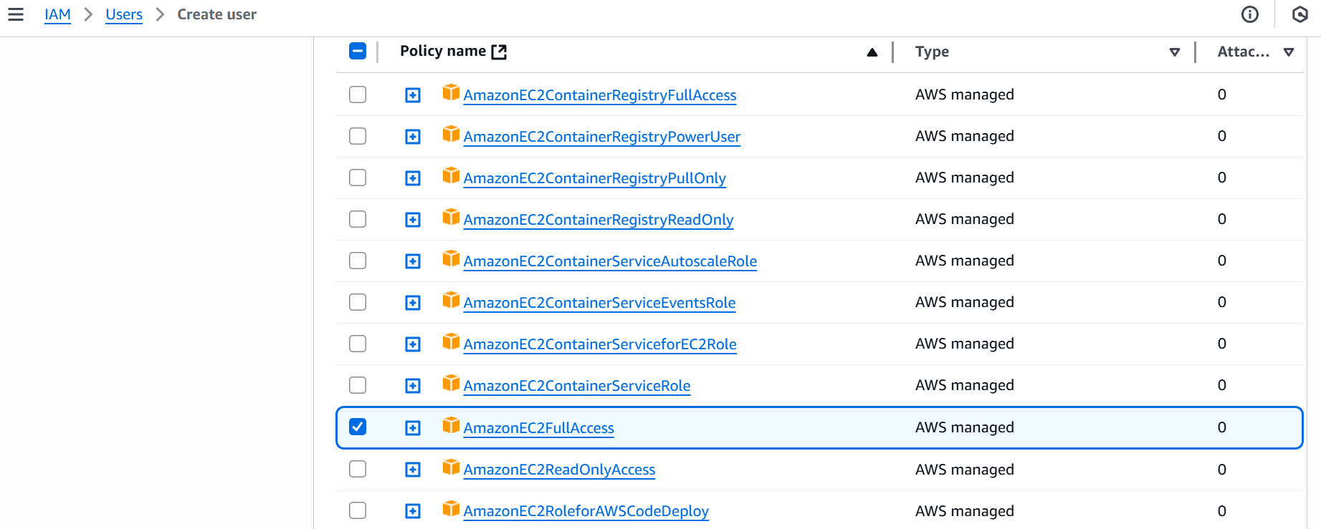

S3 Full access

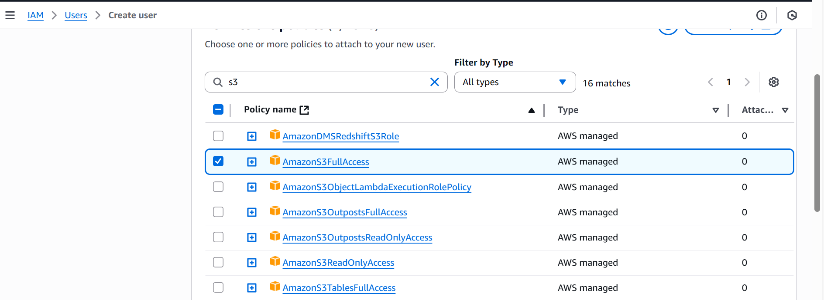

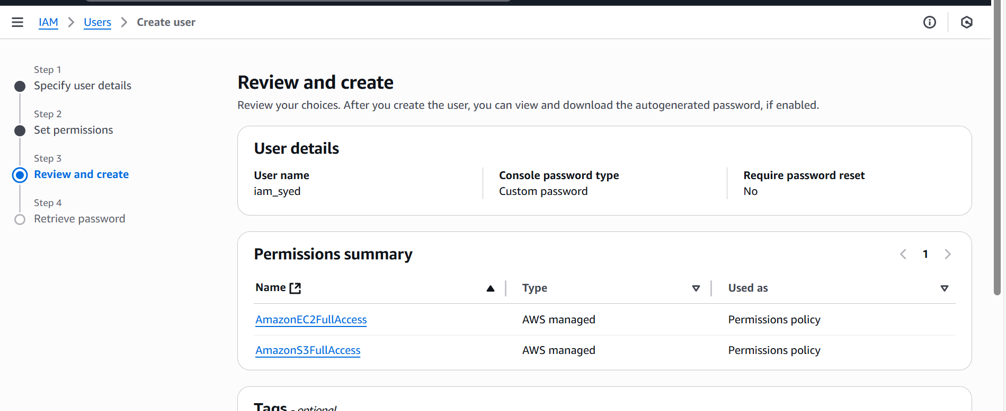

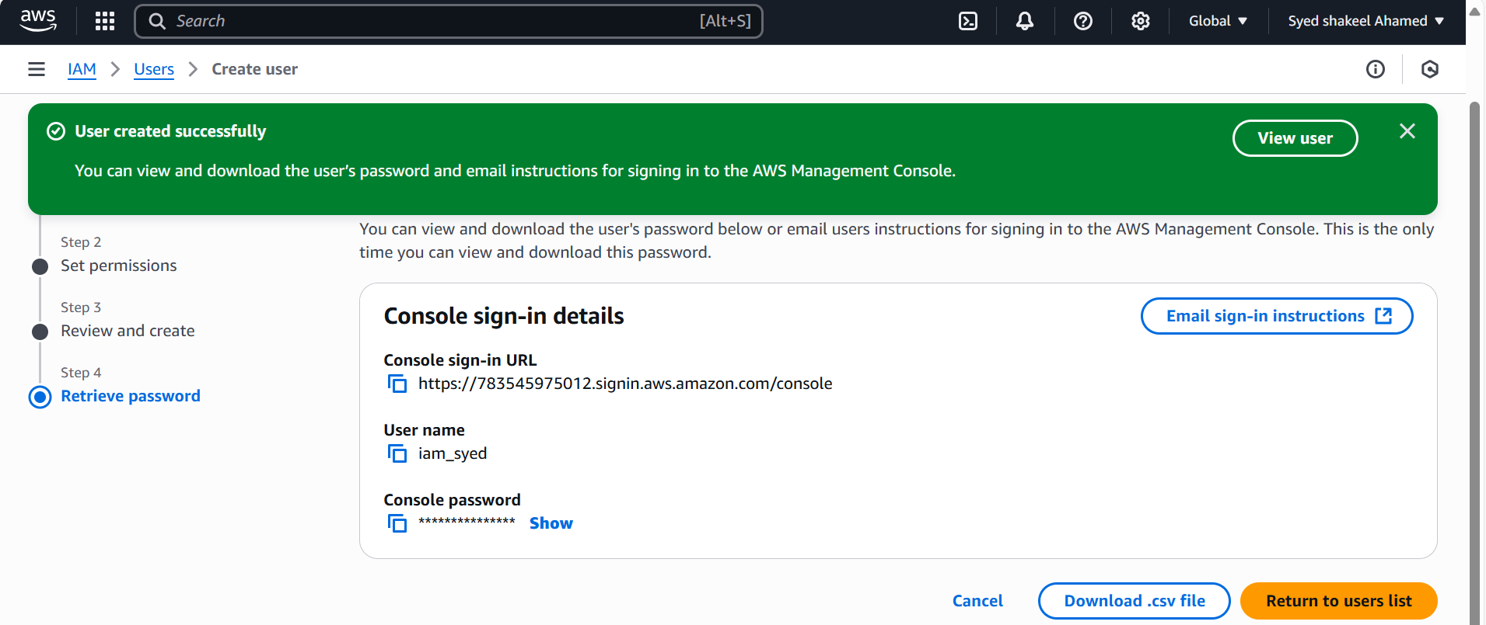

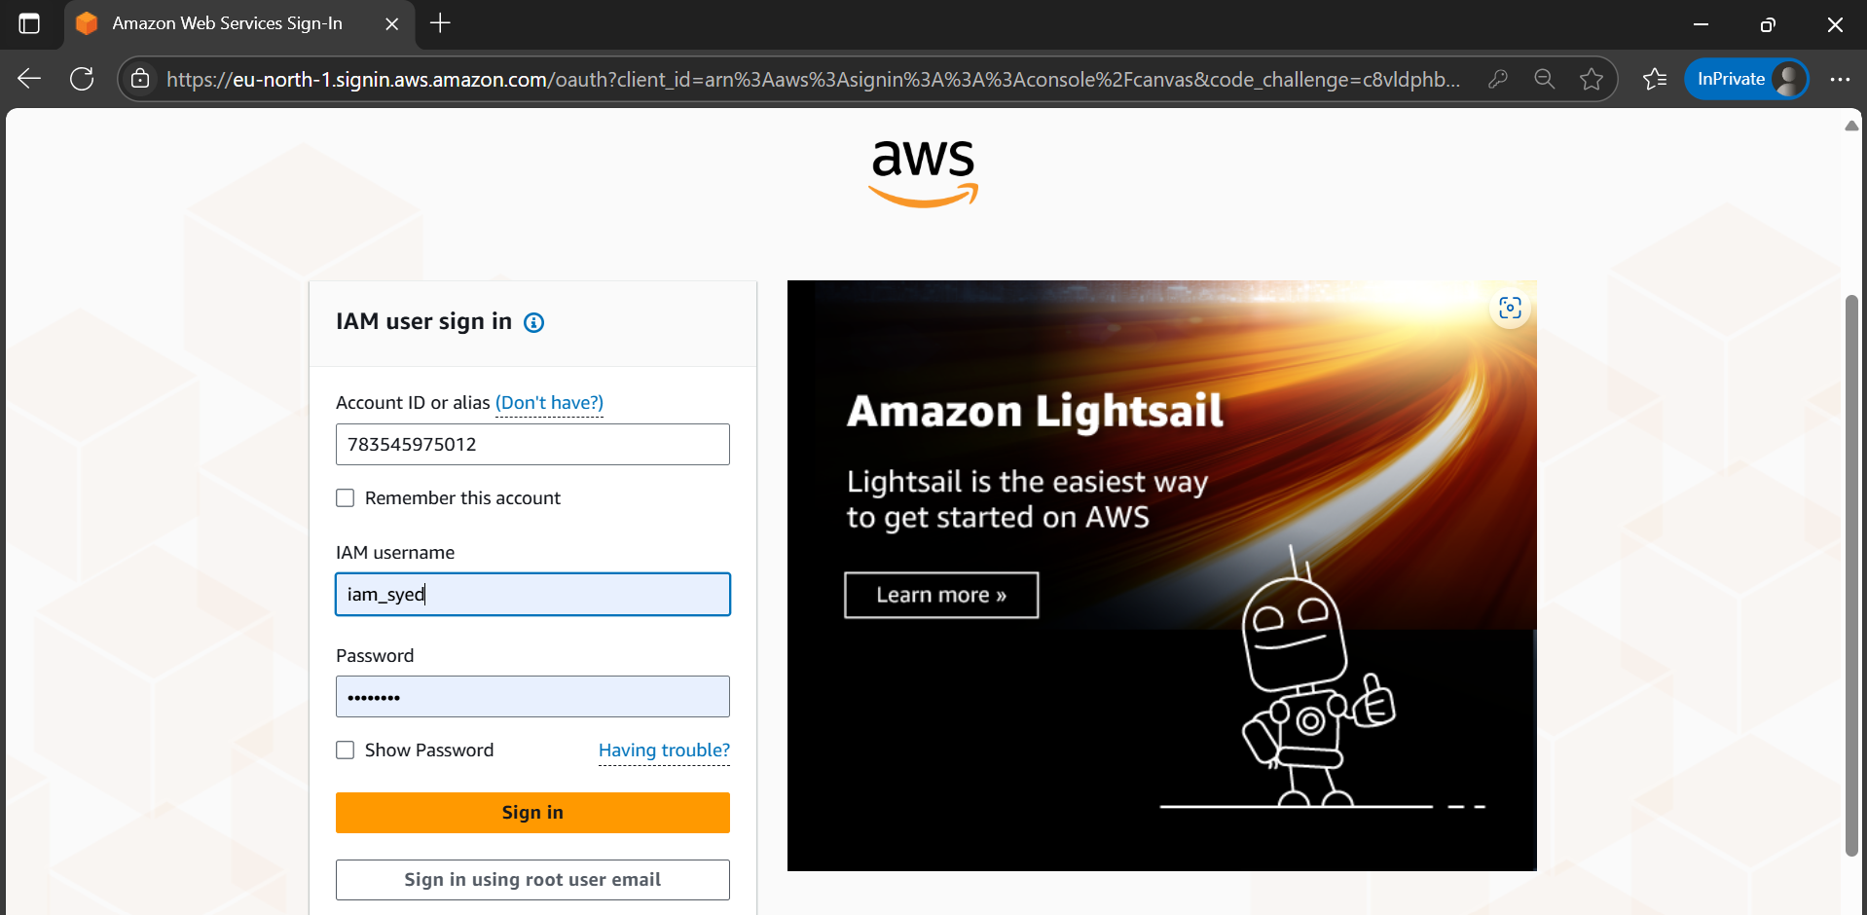

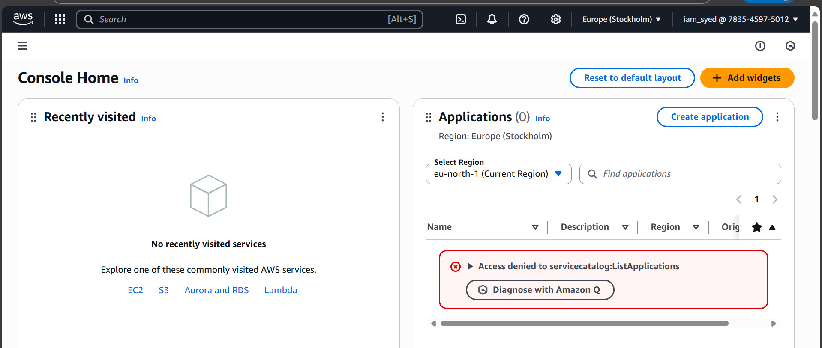

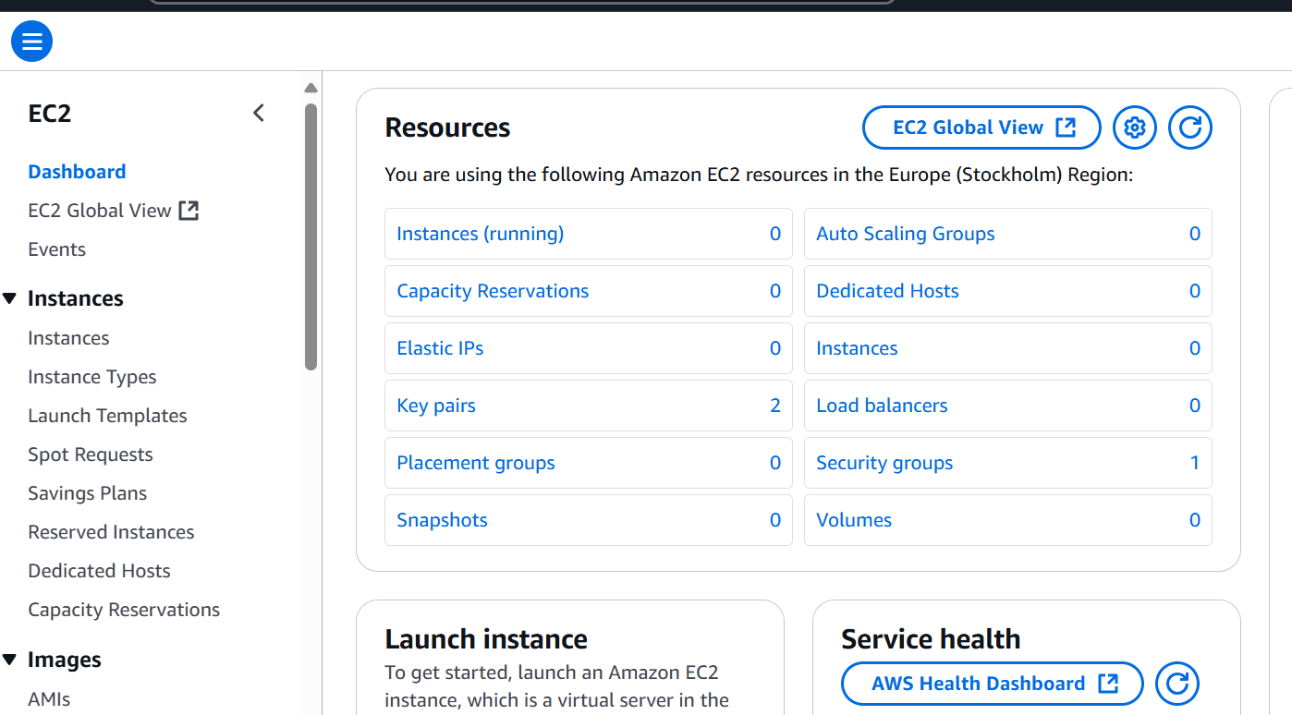

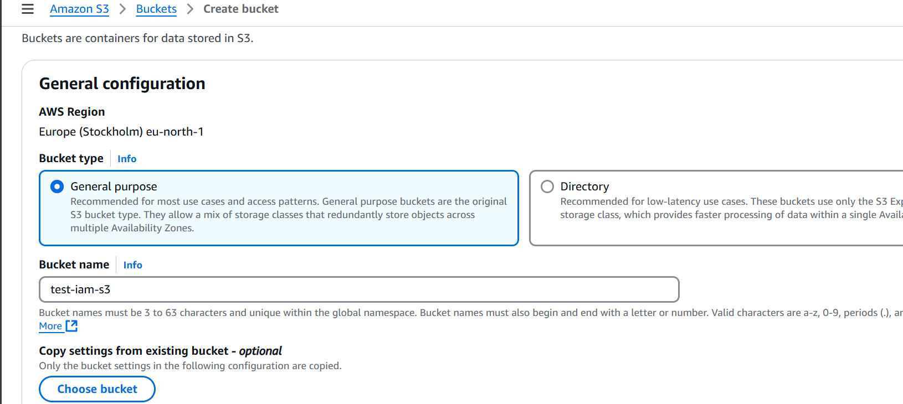

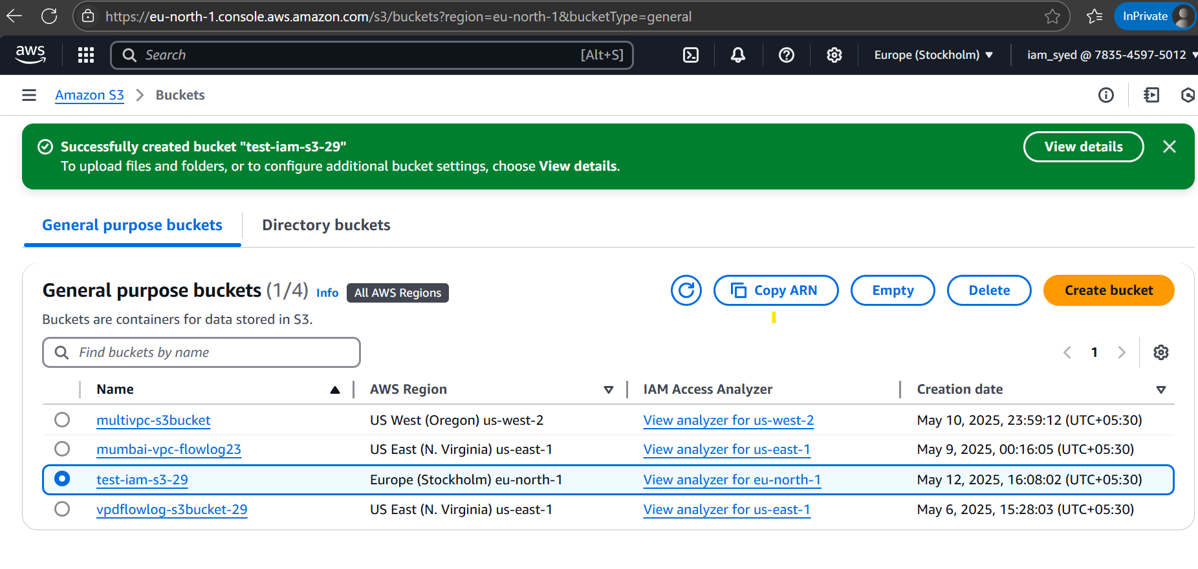  
**2) Create one Group in IAM and Assign Read access for ec2.**

Create an IAM Group

Access IAM Console

- Sign in to the AWS Management Console.

- Navigate to IAM.

Create a New Group

- Click on “User Groups” in the left panel.

- Click “Create Group”.

- Enter a Group Name, e.g., "Devops".

- Click “Next”.

Attach EC2 Read-Only Policy

Assign IAM Policy

- Search for AmazonEC2ReadOnlyAccess policy.

- Select the checkbox next to it.

- Click “Next”, then “Create Group”.

Add Users to the Group

Assign Users- Click on the newly created group.

- Navigate to the “Users” tab.

- Click “Add Users”.

- Select the users you want to grant EC2 read-only access.

- Click “Add Users”.

Verify Permissions

Test User Access- Log in as a user in this group.

- Navigate to EC2 Console.

- Try viewing instances—you should have read-only access.

- Attempt creating/modifying instances—this should be denied.







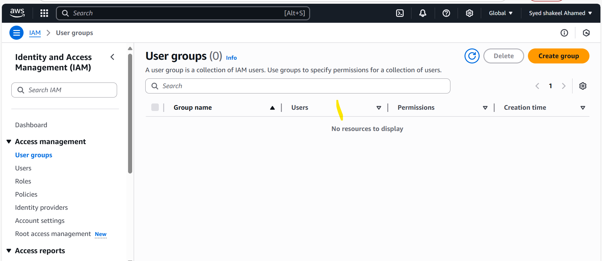

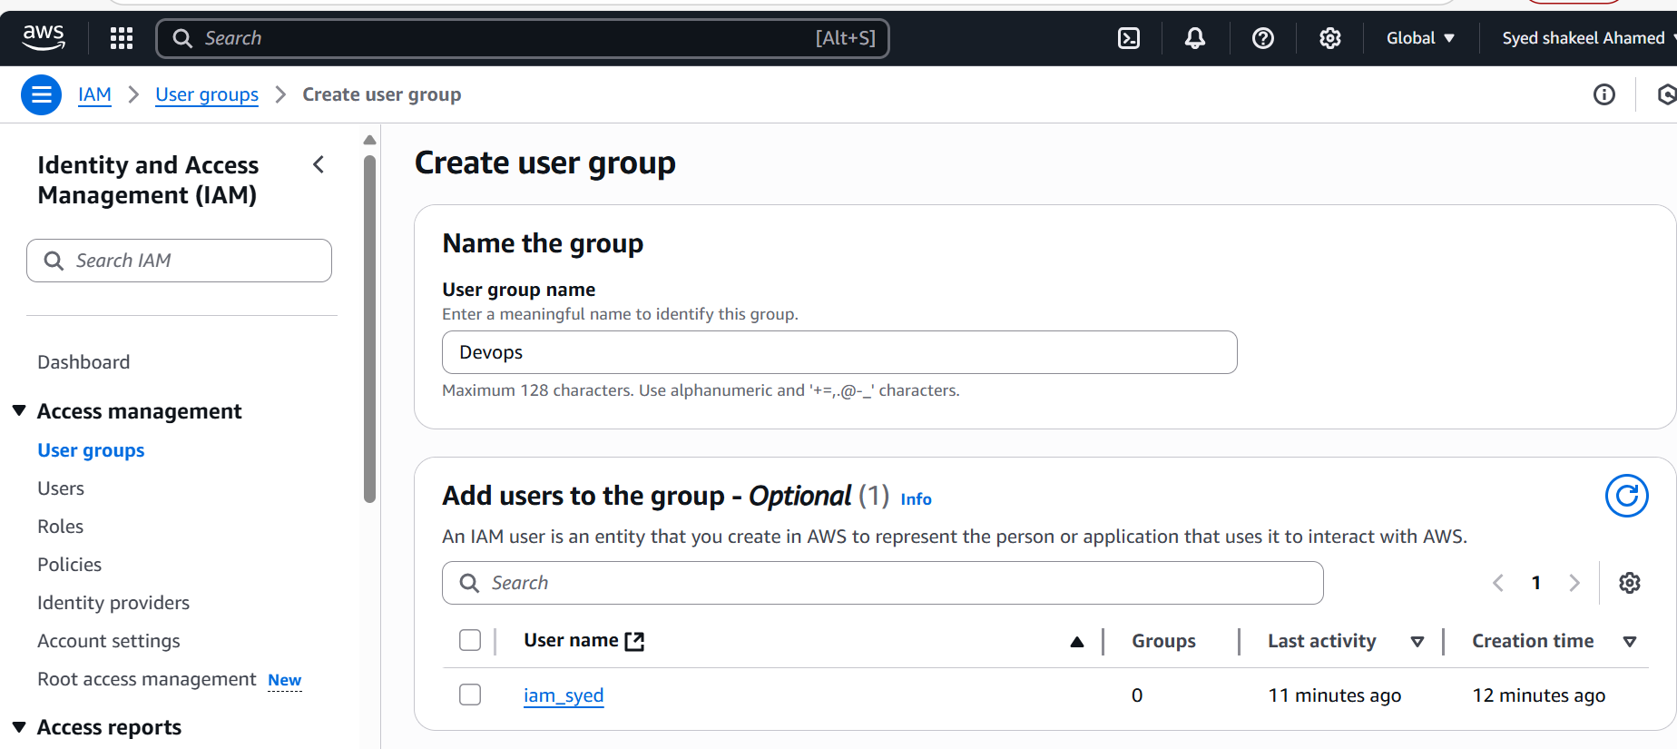

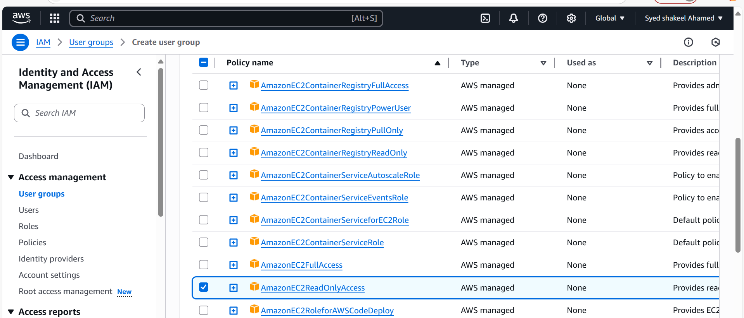

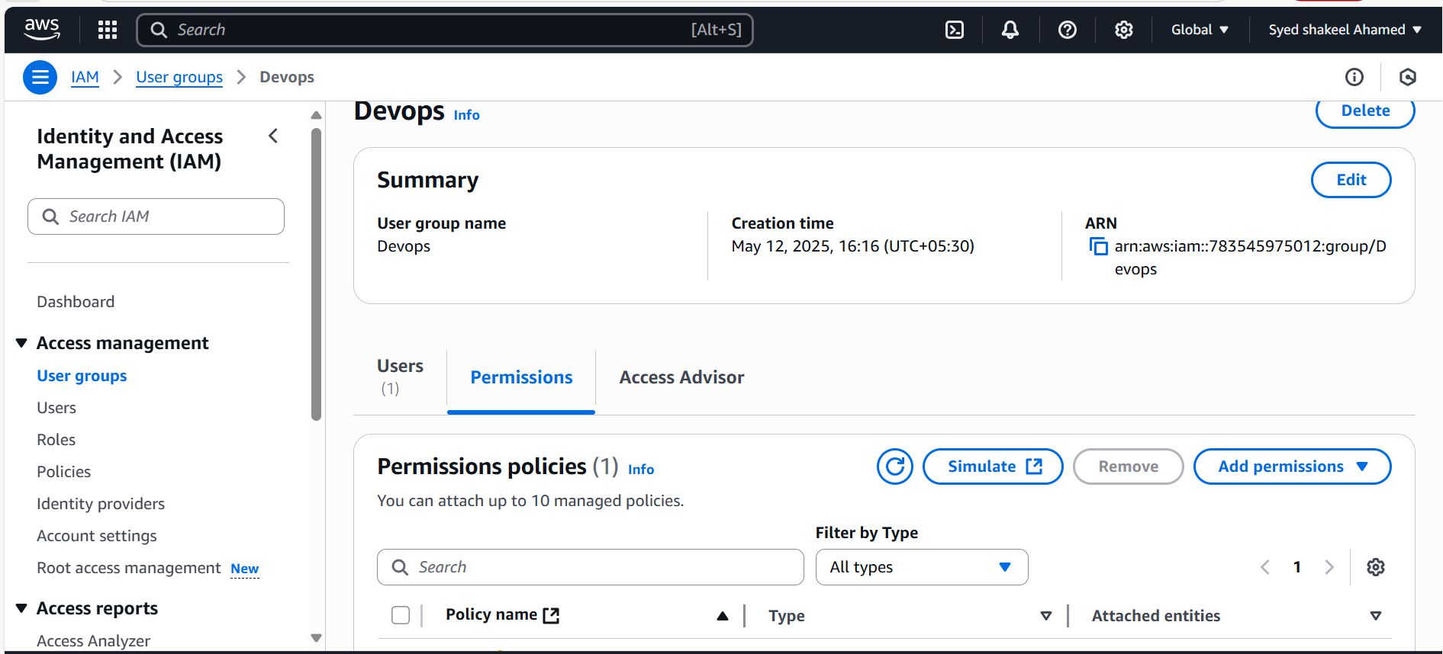

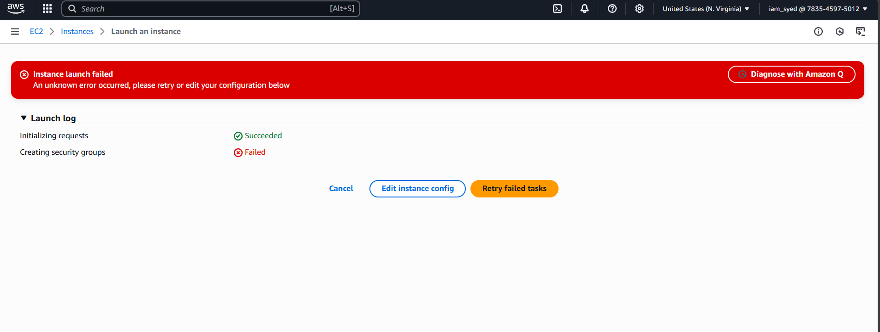

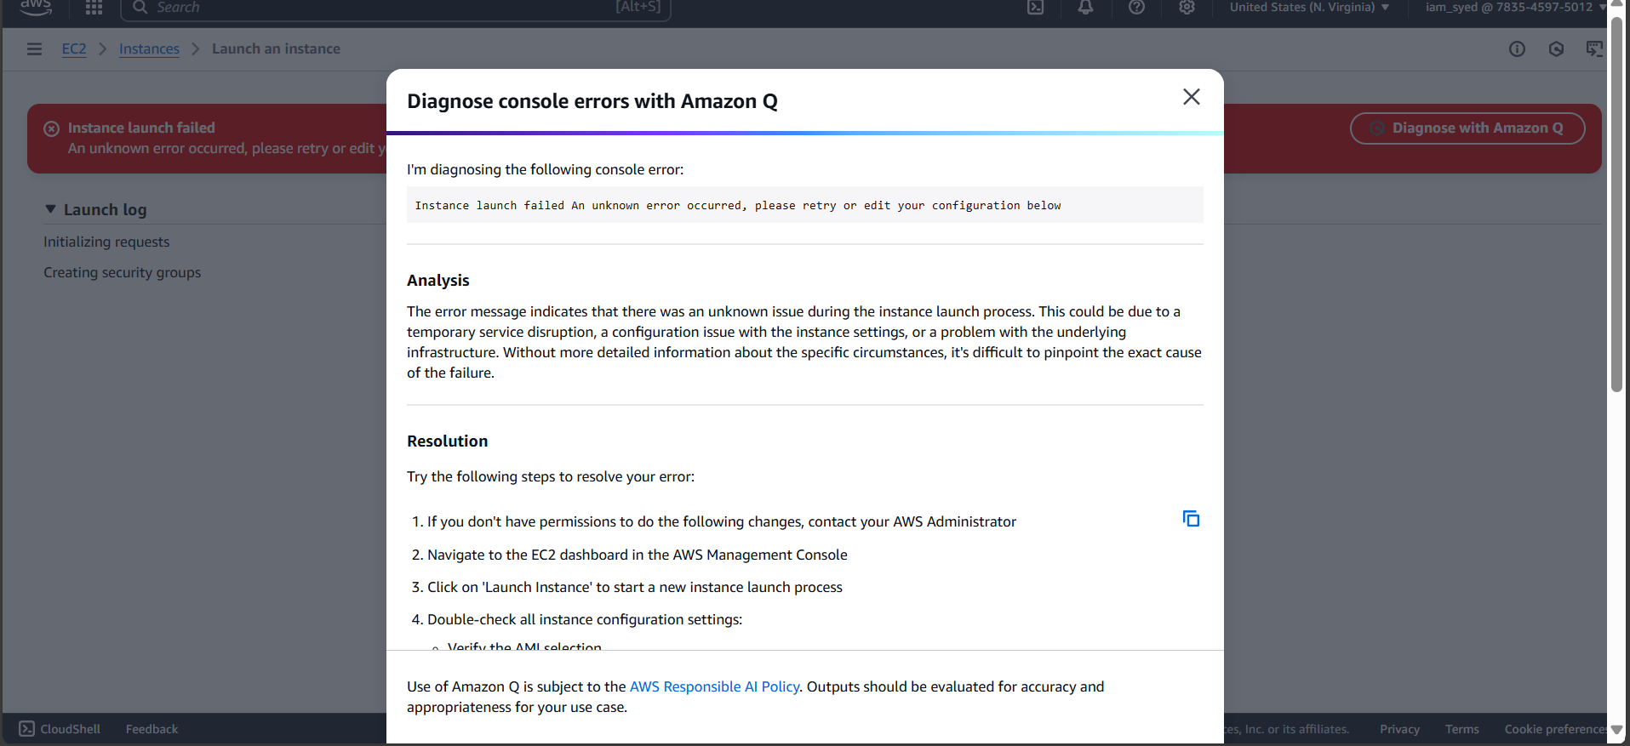

**3) Create a new user with name Devops and add to the group created in task2.**

Create a New IAM User

Access IAM Console

- Sign in to the AWS Management Console.

- Navigate to IAM.

Create a New User

- Click “Users” in the left panel.

- Click “Add users”.

- Enter User Name → Devops.

- Choose “Access Key - Programmatic Access” if the user needs AWS CLI/API access.

- Choose “AWS Management Console access” if the user needs to log into AWS UI.

- Set Custom Password (optional).

- Click “Next”.

Assign User to the Group

Select the IAM Group

- In the Permissions section, click “Add user to group”.

- Select the group EC2ReadOnlyGroup.

- Click “Next”.

Verify User Details & Create

Review & Create- Review the user’s permissions.

- Click “Create User”.

- You will see a Success Message with user details.

Retrieve Credentials

Download User Credentials- Click “Download .CSV” file containing:

- User Access Key ID

- Secret Access Key

IMPORTANT: Save this file securely—it won’t be visible again!

Test User Access

Log in as Devops- Sign in using the Devops IAM credentials.

- Navigate to EC2 Console.

- Try viewing instances—should have read-only access.

- Attempt modifying instances—should be denied.

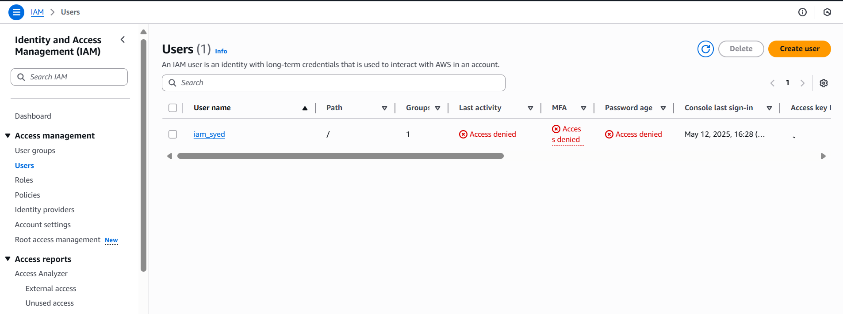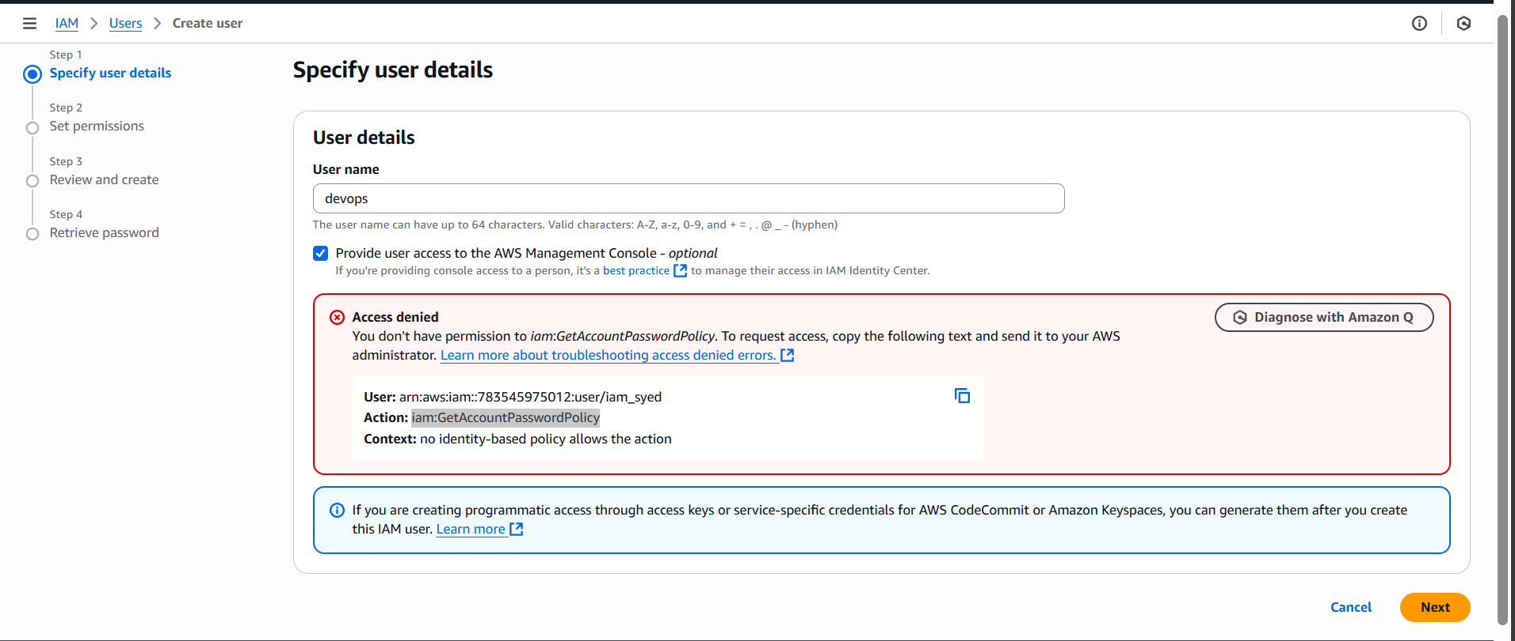  
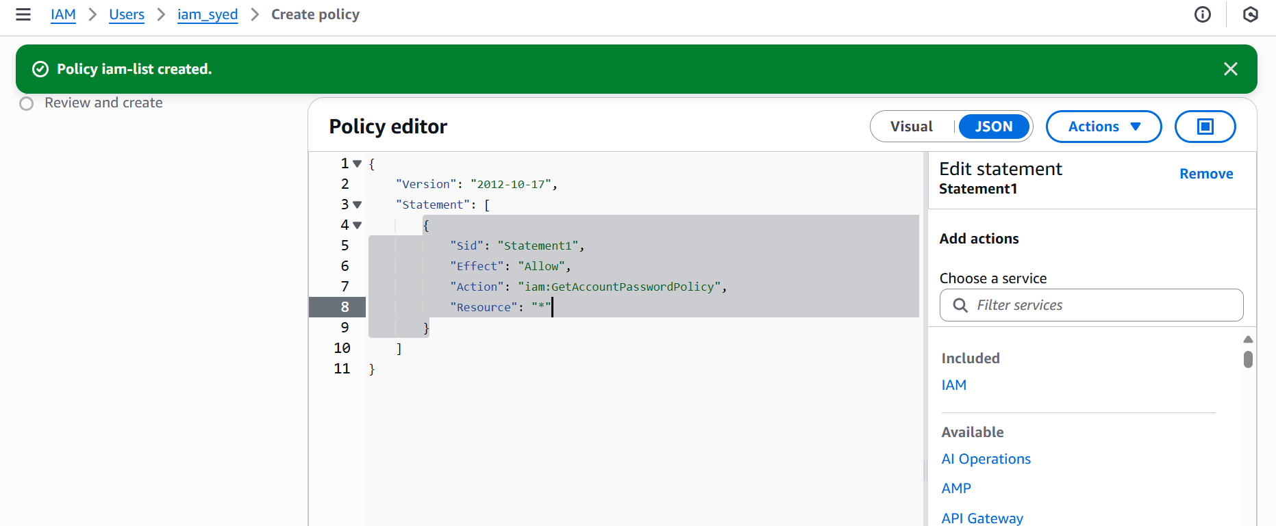

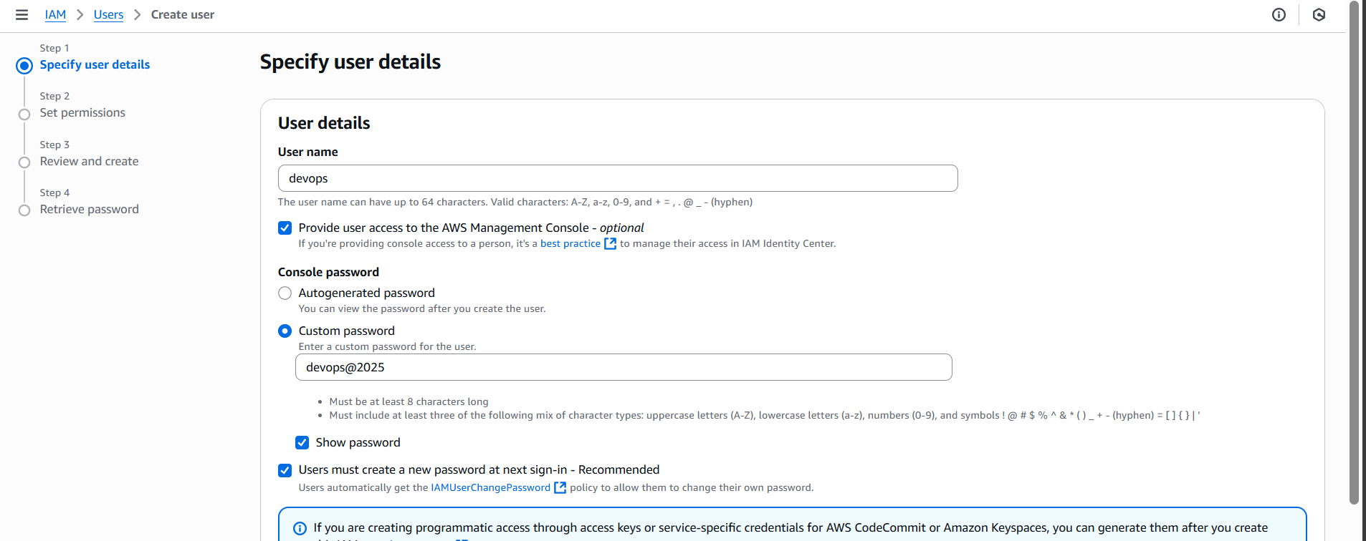

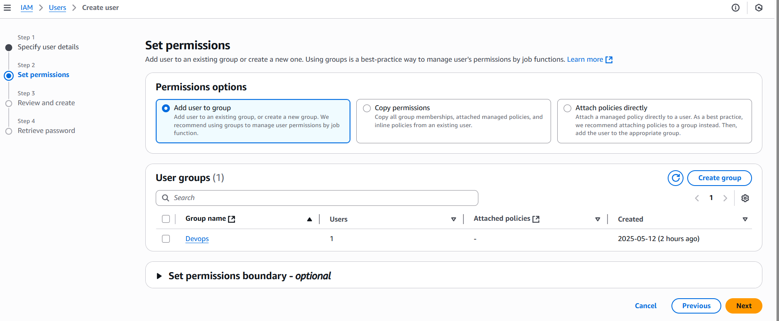

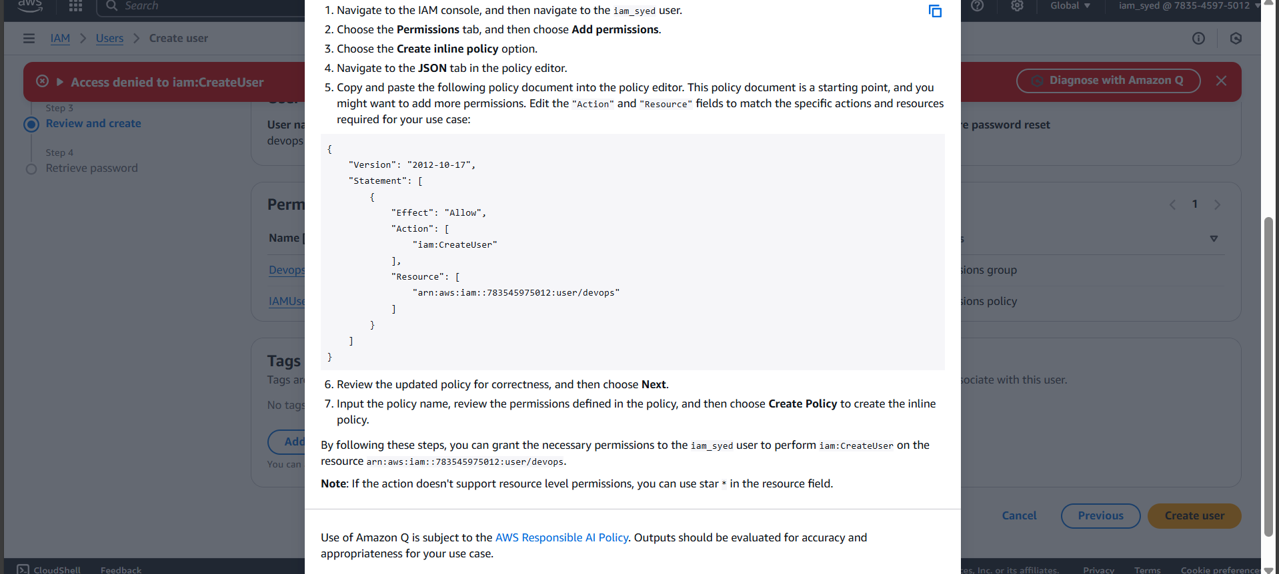

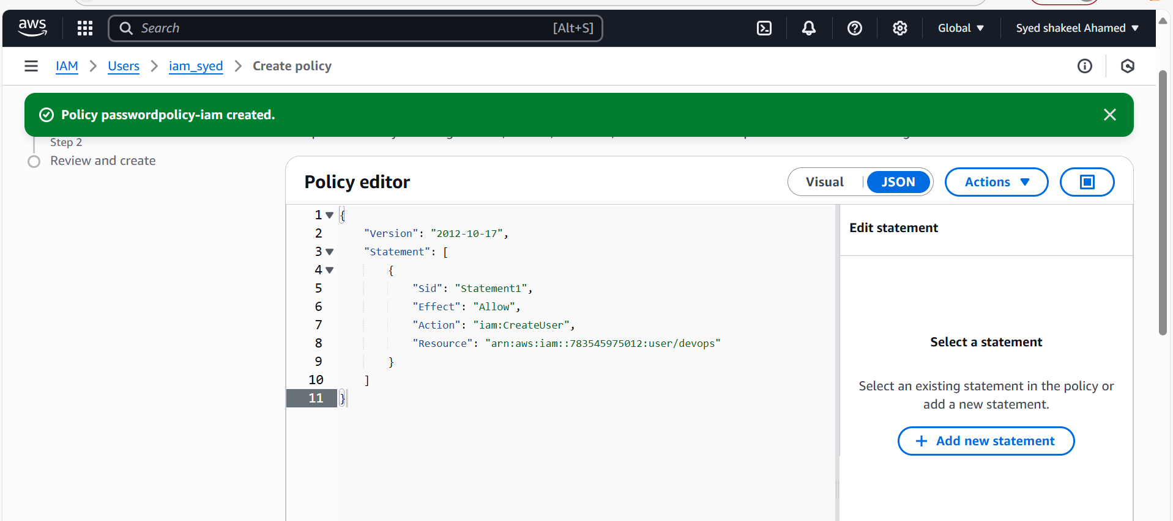

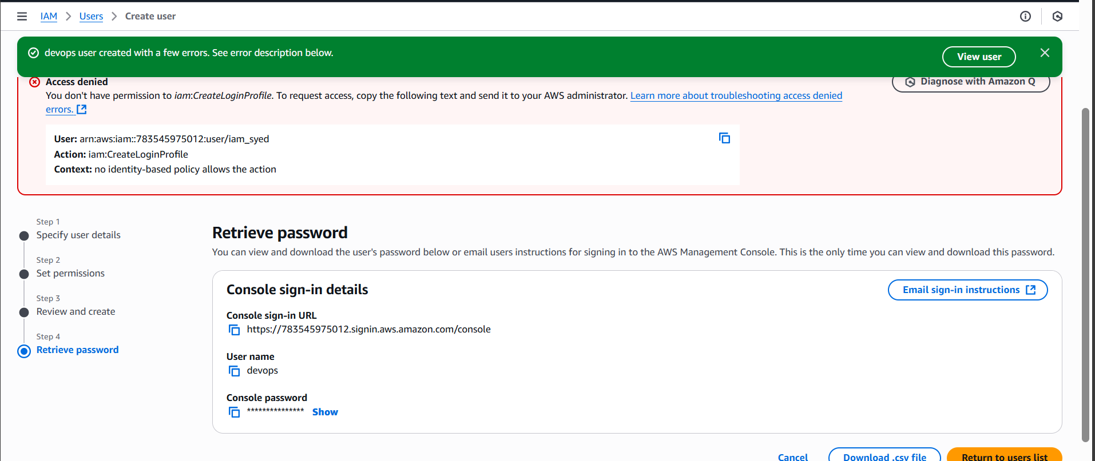

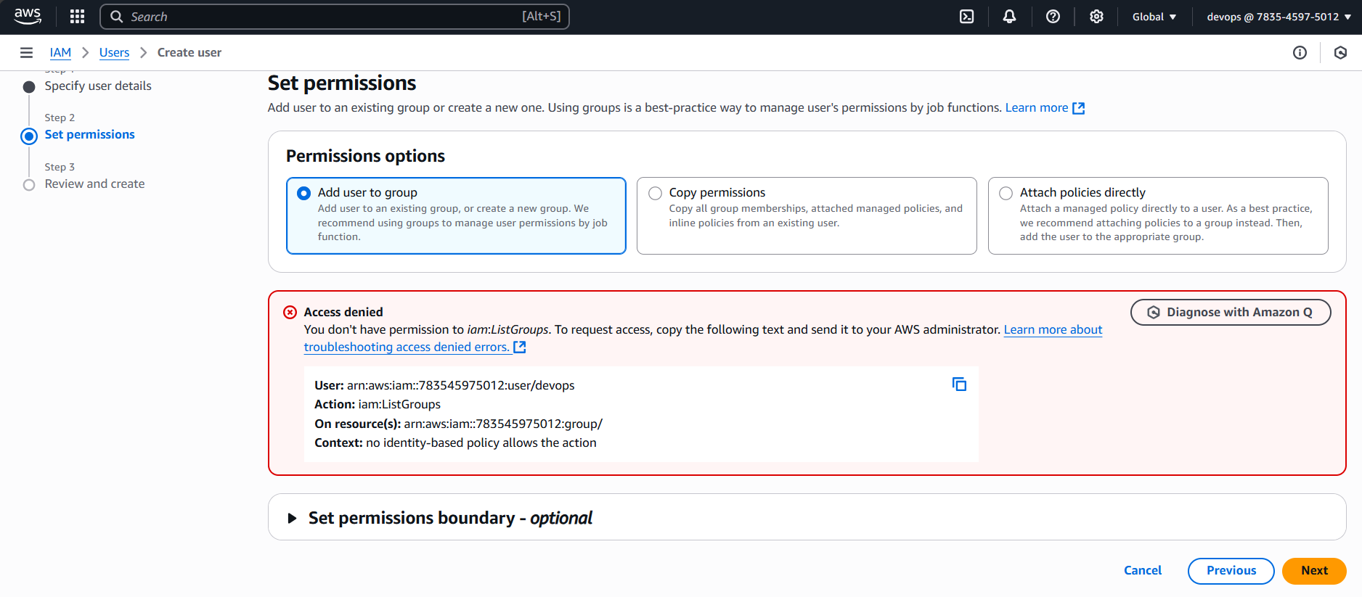

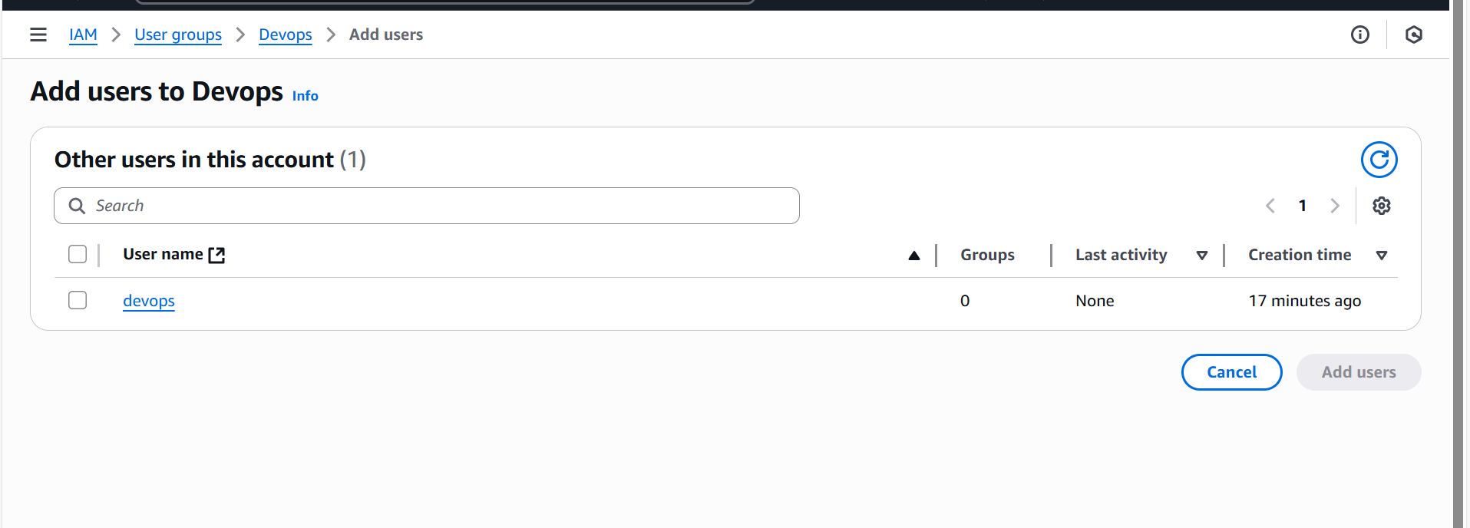

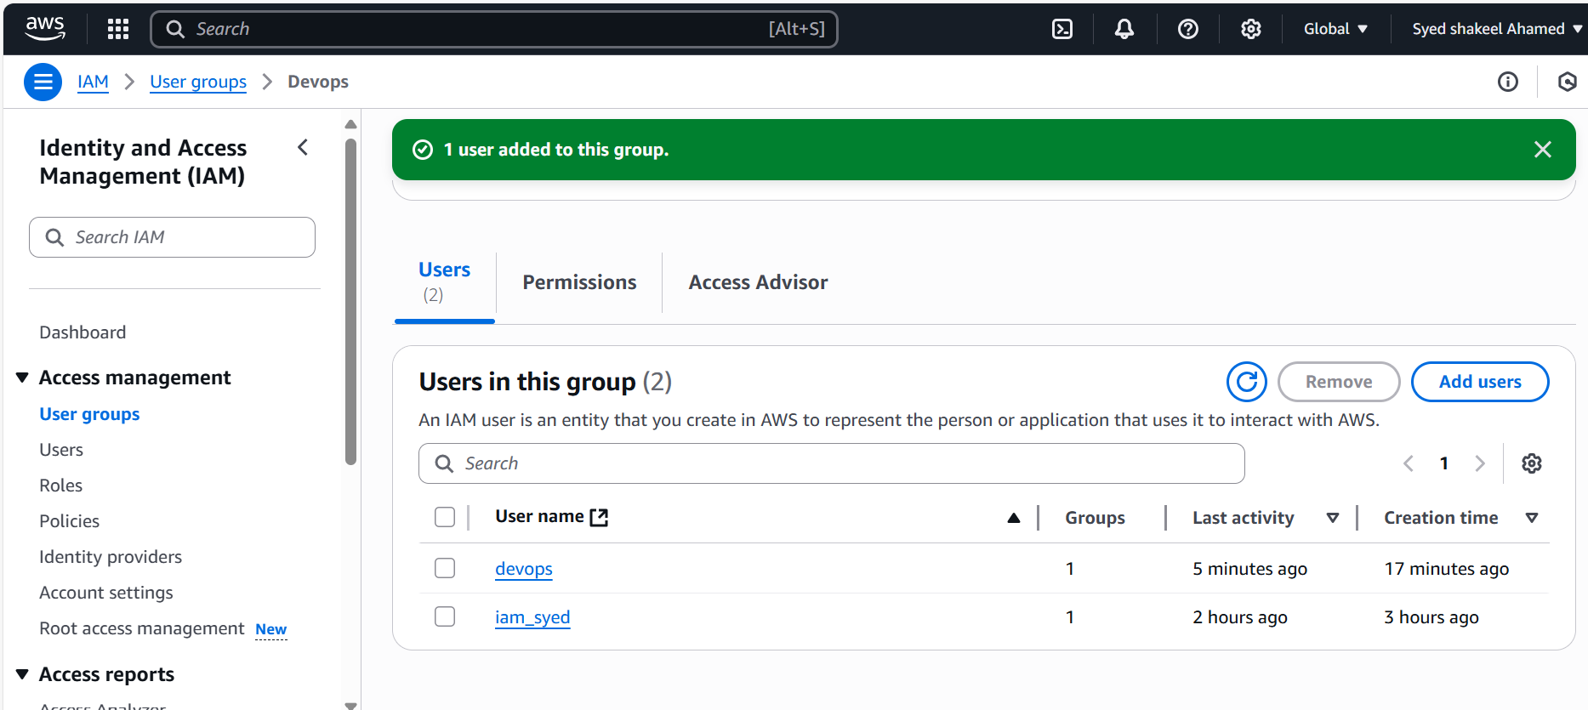

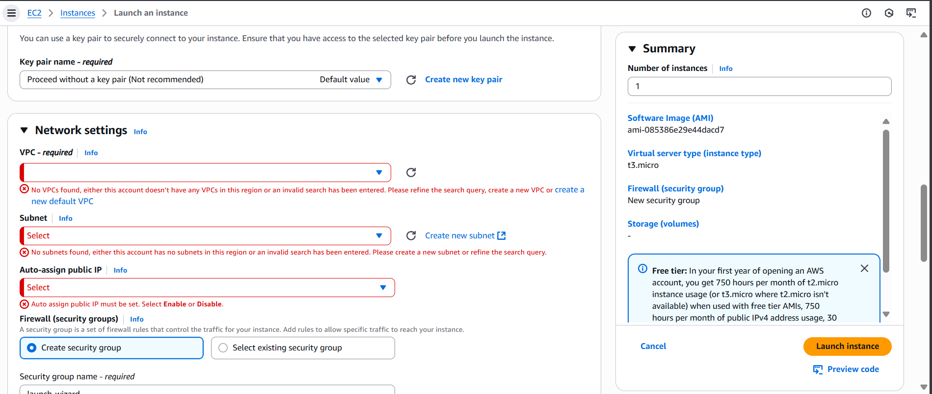

**4) Write a bash script to create a IAM user with VPC full access.**

Prerequisites Before running the script, ensure:

* AWS CLI is installed → Run: aws --version
* If not installed, follow AWS CLI Installation Guide.
* You have Admin IAM permissions to create users and attach policies.
* You have configured AWS CLI with credentials: aws configure Bash Script to Create an IAM User with Full VPC AccessSave this script as create_iam_user.bash Running the Script- Give execution permissions: chmod +x create_iam_user.bash
* Run the script: ./create_iam_user.bash Verify IAM User & Permissions- Confirm user creation: aws iam list-users | grep DevOpsUser
* Check attached policy: aws iam list-attached-user-policies --user-name DevOpsUser
* Validate VPC access: aws ec2 describe-vpcs

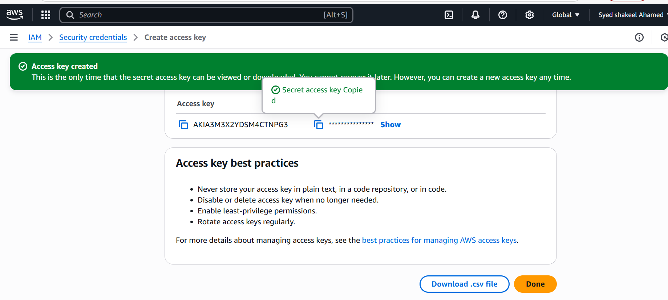

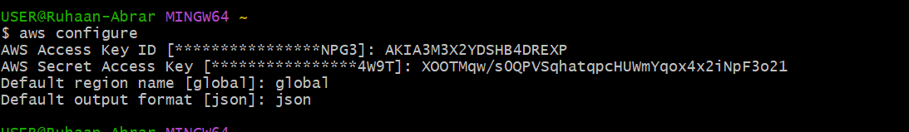

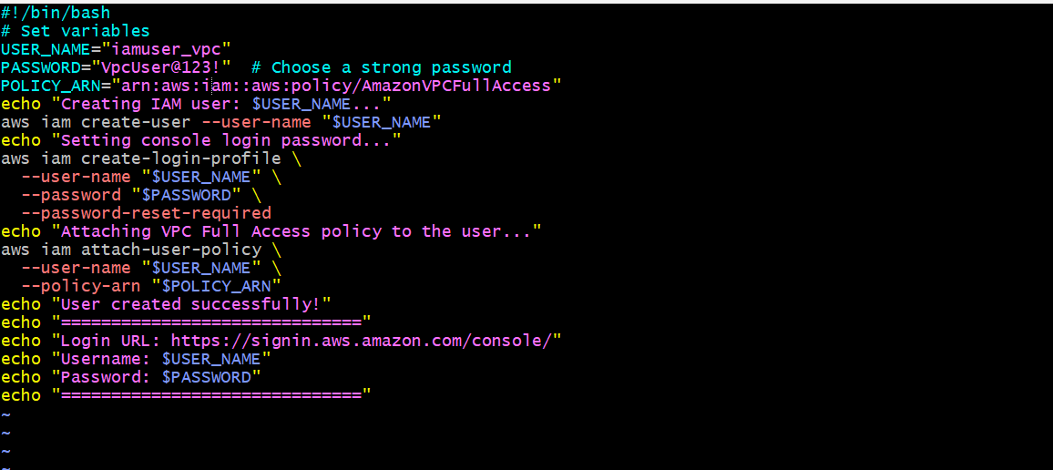

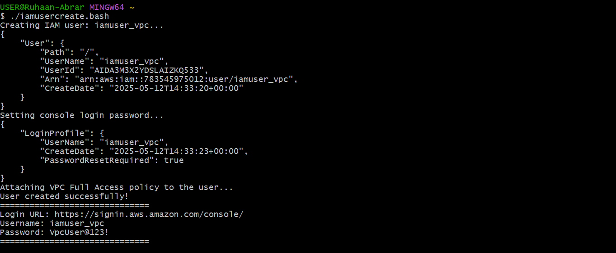

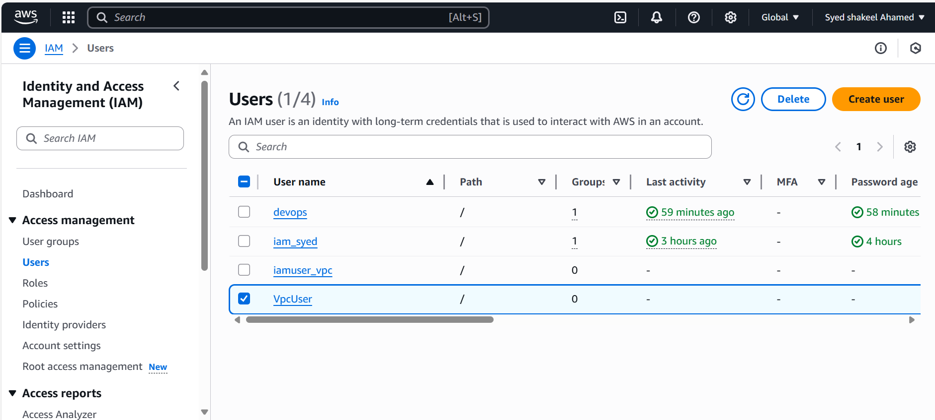

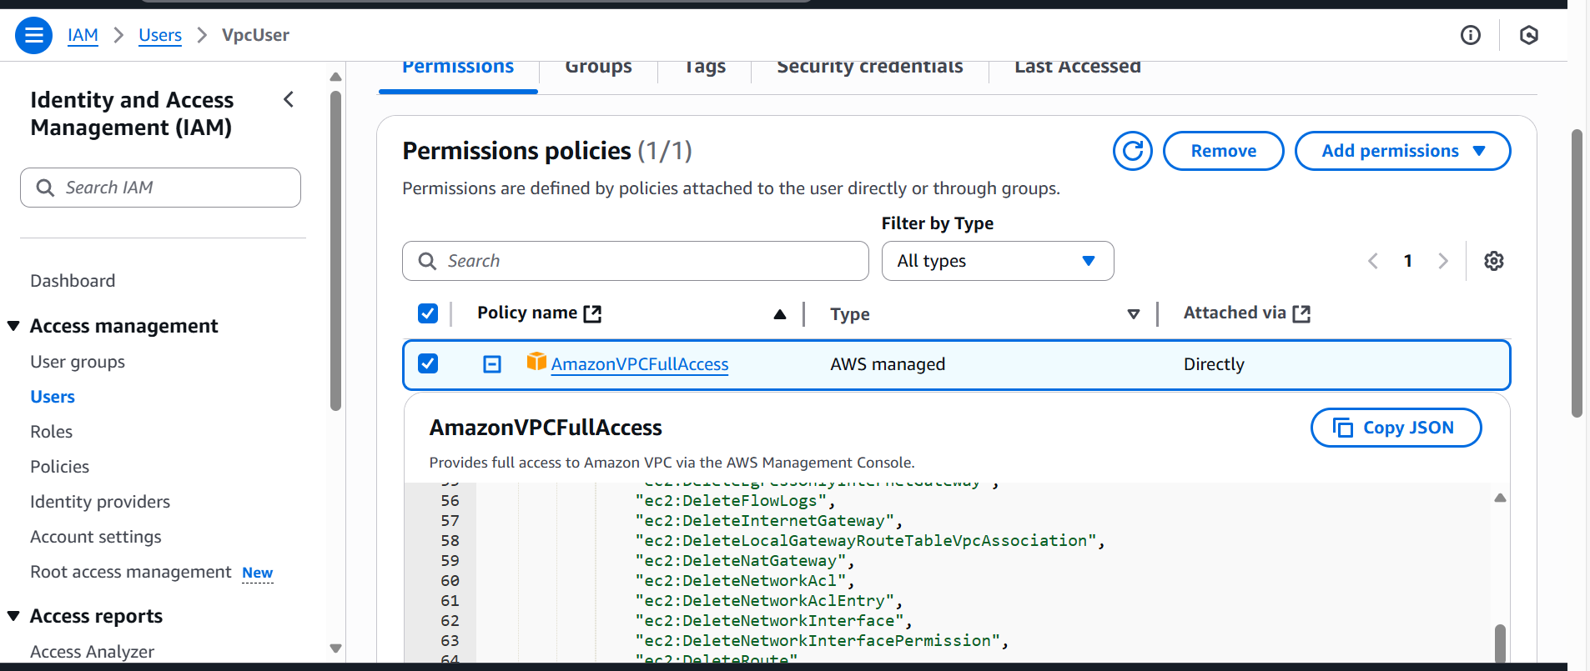

**5) Create a IAM policy to access ec2 for a specific user in specific regions only.**

Define the IAM Policy

Use the following JSON policy to restrict EC2 access for a specific IAM user:

{

"Version": "2012-10-17",

"Statement": [

{

"Effect": "Allow",

"Action": "ec2:*",

"Resource": "*",

"Condition": {

"StringEquals": {

"aws:RequestedRegion": [

"us-east-1",

"ap-south-1"

]

}

}

}

]

}

How It Works

✅ Allows all EC2 actions (ec2:*) for the user.

✅ Restricts actions only to us-east-1 and ap-south-1 regions.

❌ Access will be denied if attempted in other regions.

Create the IAM Policy

Open AWS IAM Console

- Sign in to AWS and navigate to IAM.

- Click on “Policies” in the left panel.

- Click “Create Policy”.

Define the Policy

- Select “JSON” tab.

- Paste the JSON policy (above) into the editor.

- Click “Next”.

Review & Create- Enter a policy name, e.g., EC2RegionRestrictedAccess.

- Click “Create Policy”.

Attach the Policy to a User3.1 Assign IAM User- Navigate to “Users” in IAM.

- Click on the specific IAM user (e.g., iam_syed).

- Go to “Permissions” → Click “Add Permissions”.

- Select “Attach policies directly”.

- Search for EC2RegionRestrictedAccess and select it.

- Click “Next”, then “Add Permissions”.

Verify User Access4.1 Test IAM User Access- Log in as the IAM user (iam_syed).

- Try managing EC2 instances in:

- ✅ us-east-1 or ap-south-1 → Should be allowed.

- ❌ Any other region → Should be denied.

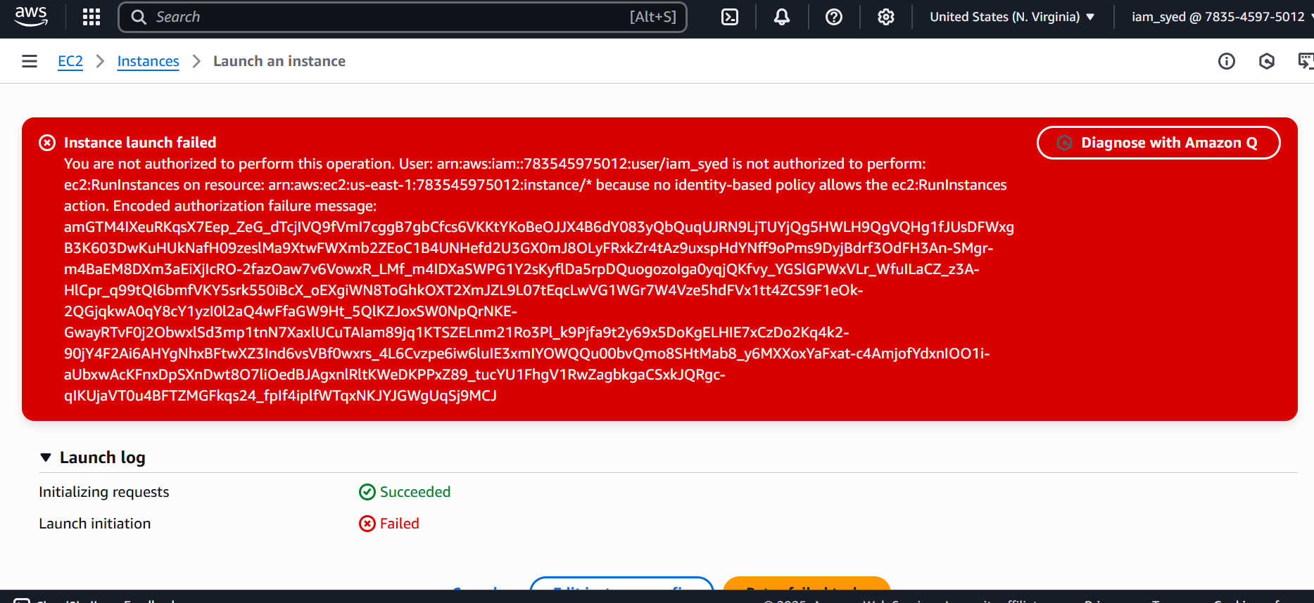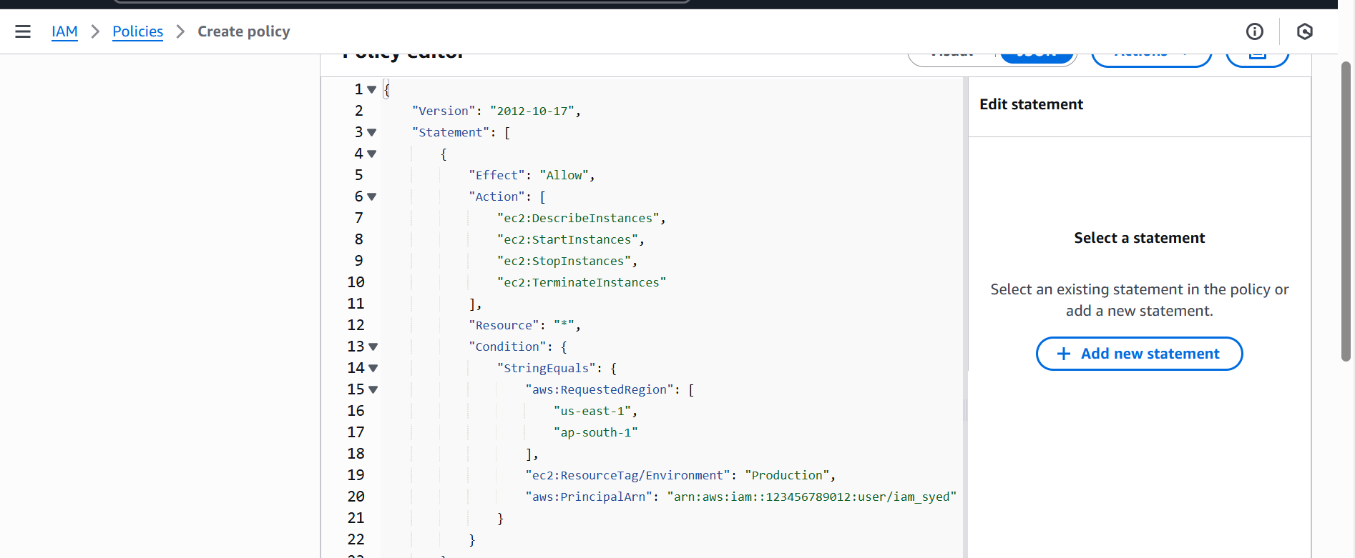

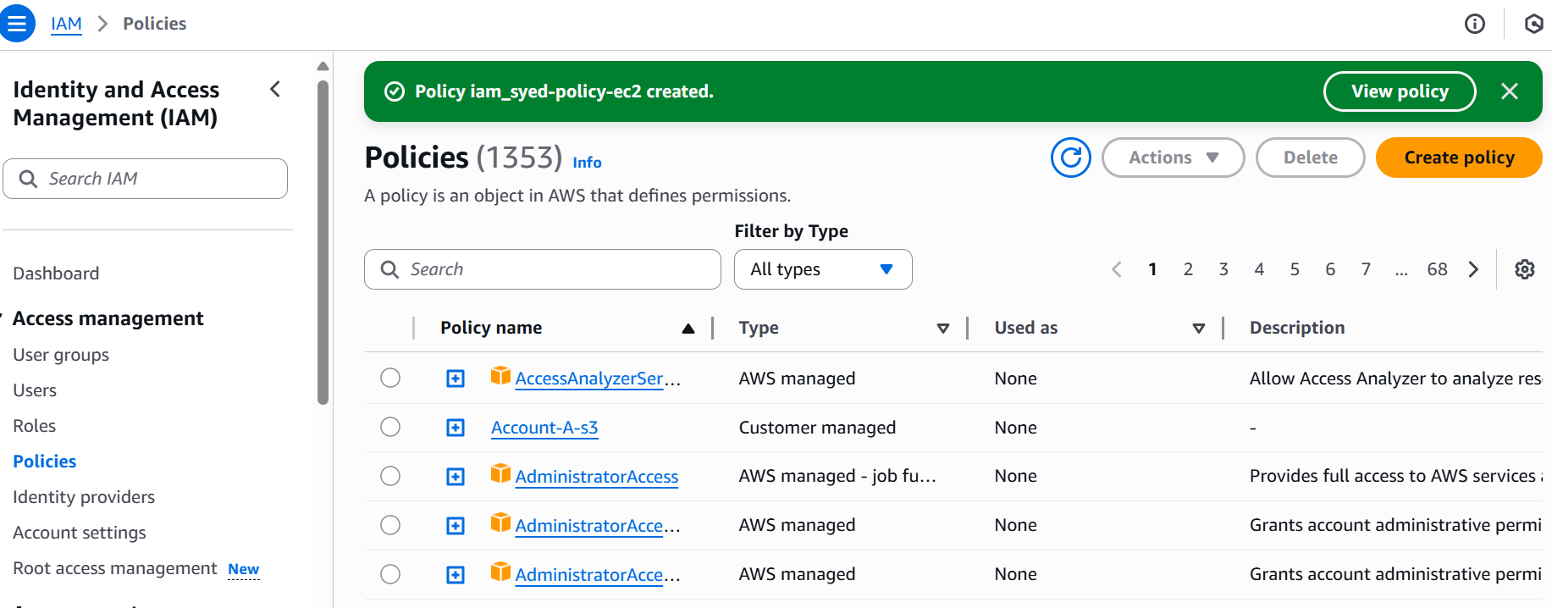

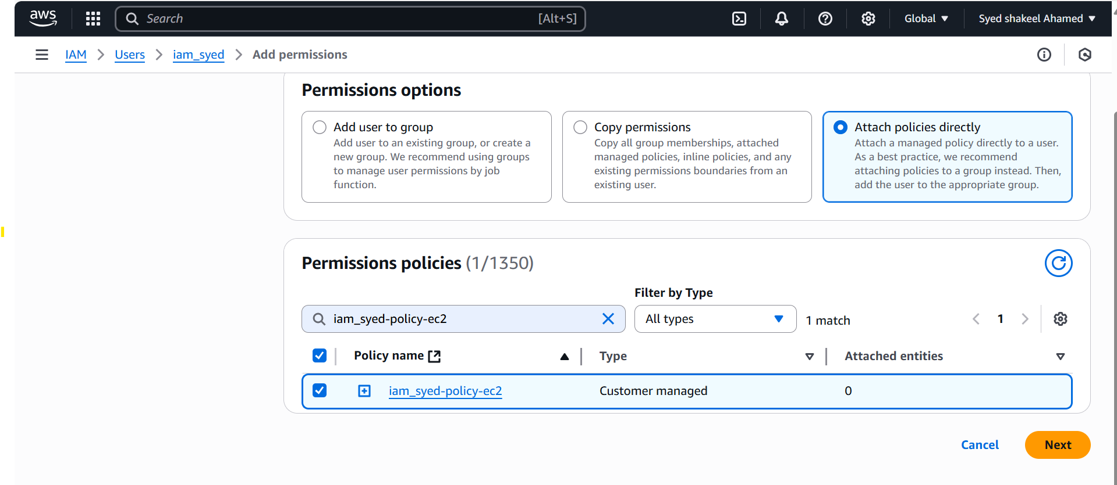

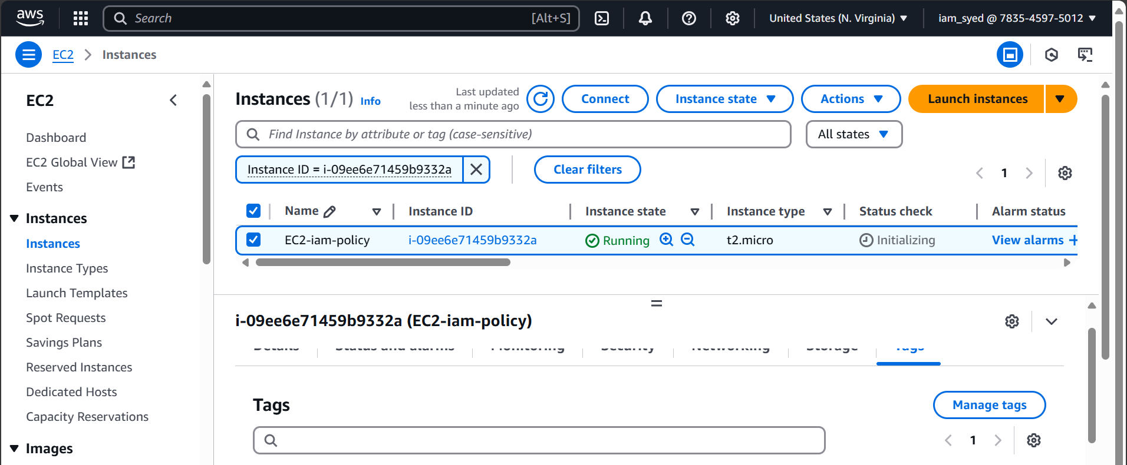

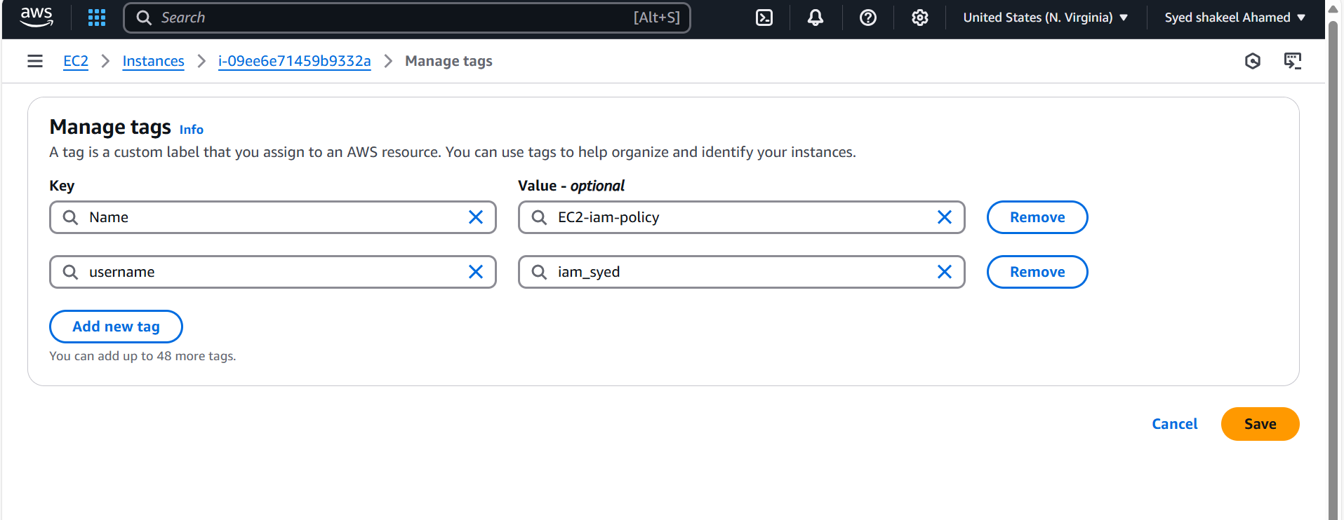

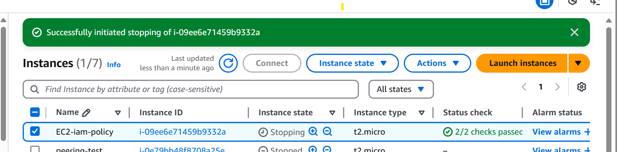

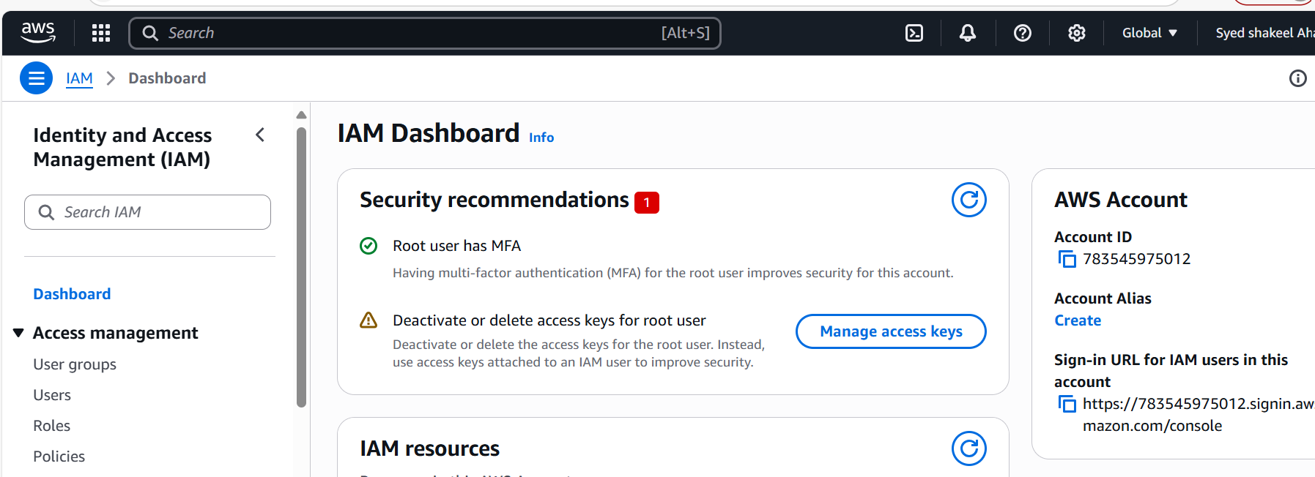

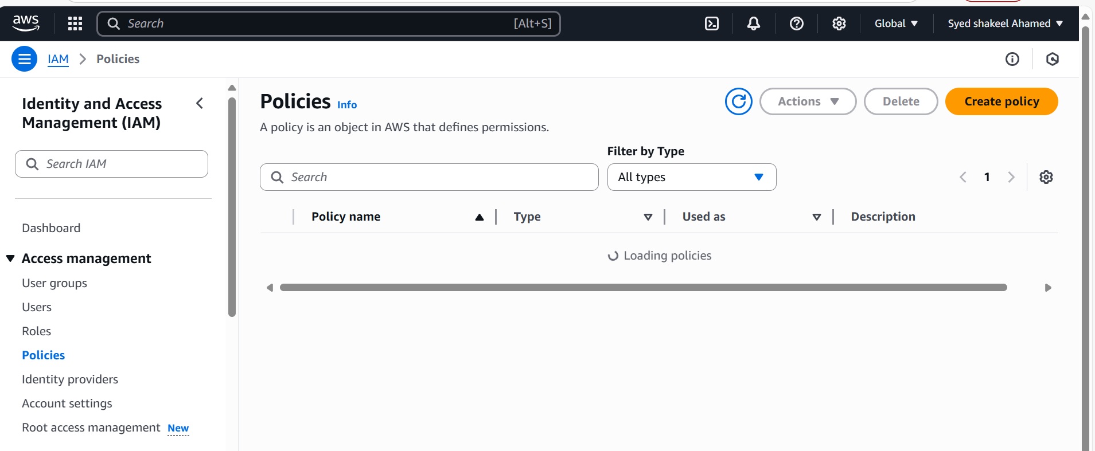

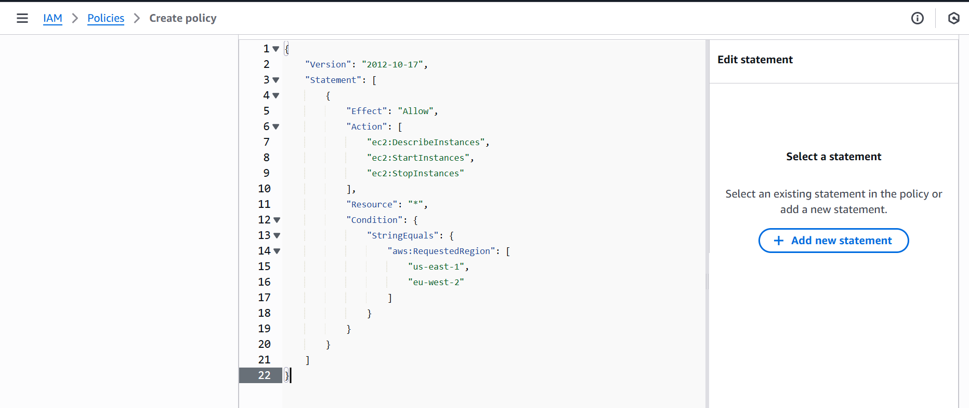

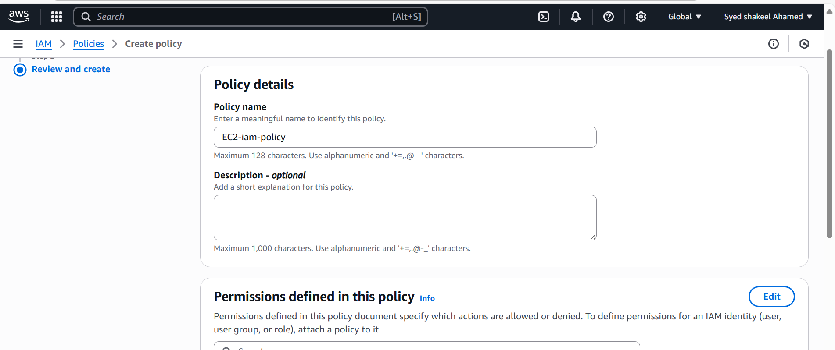

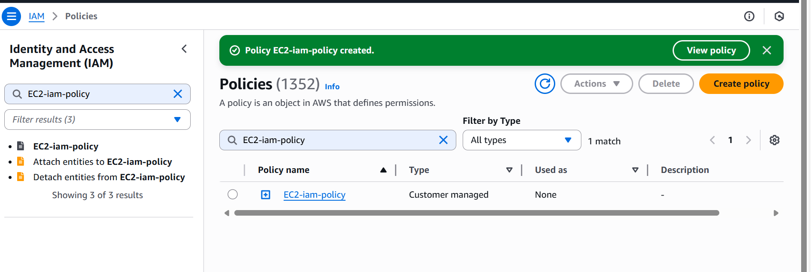

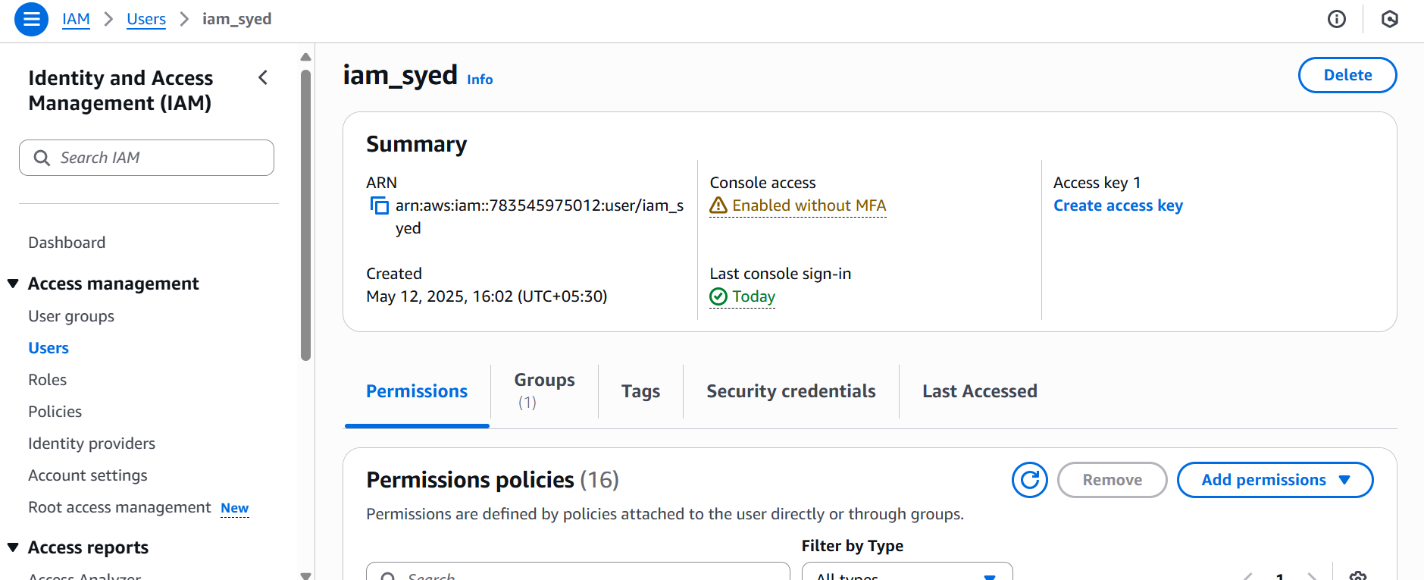

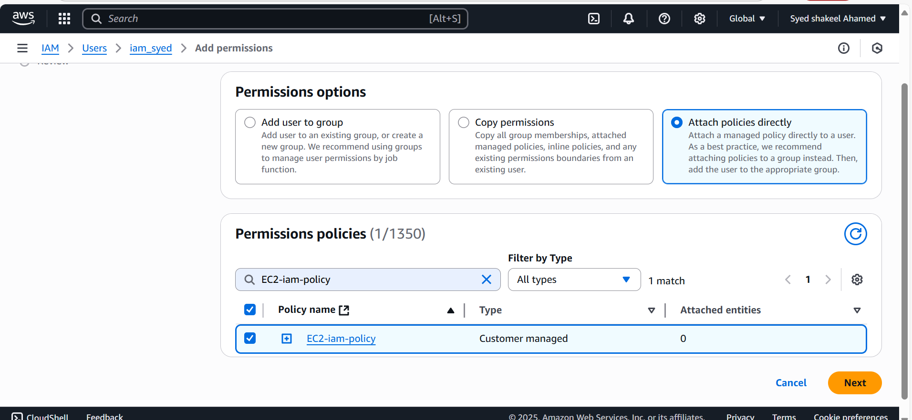

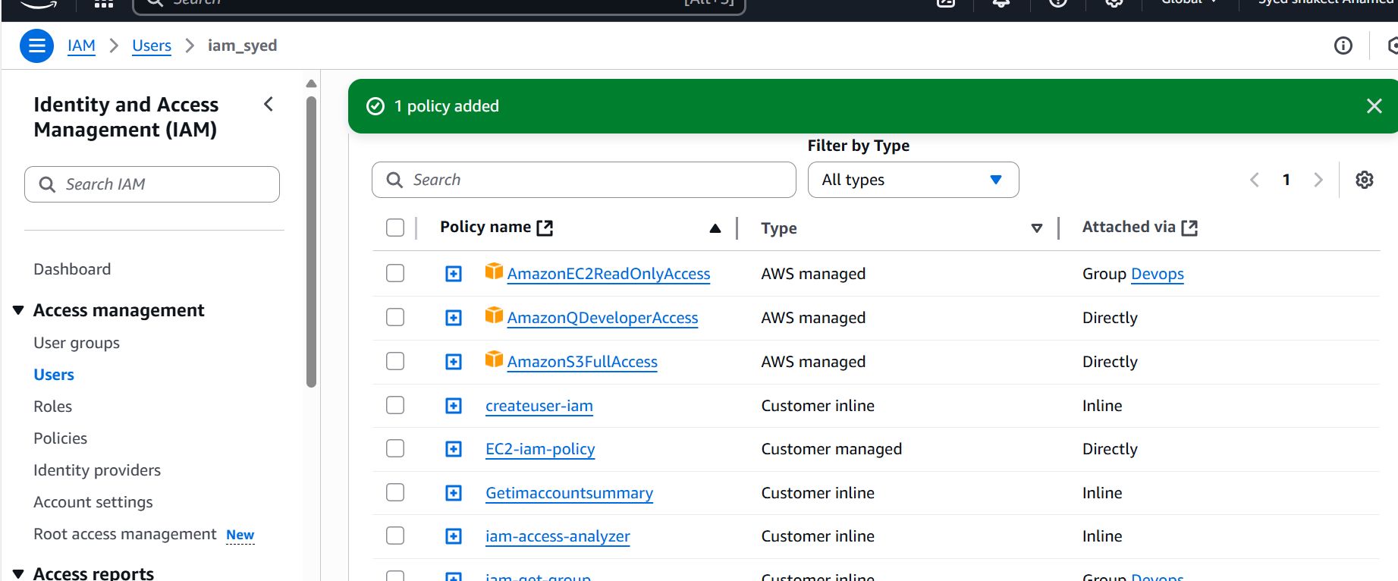

N.Virginia EC2

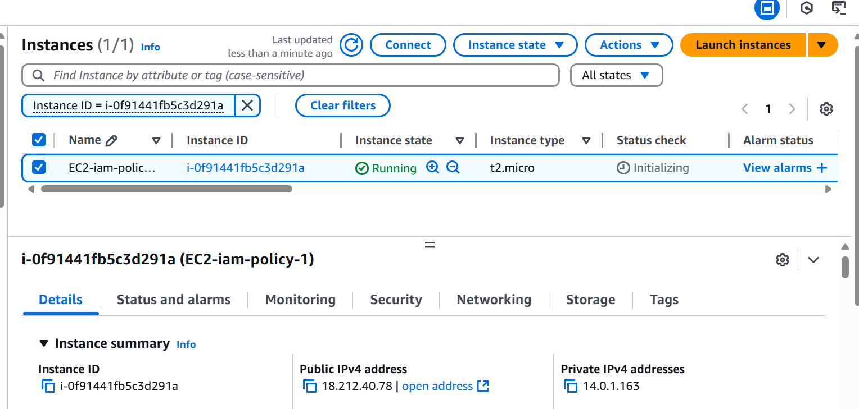

EC2-instance launching in another region (stockholm)

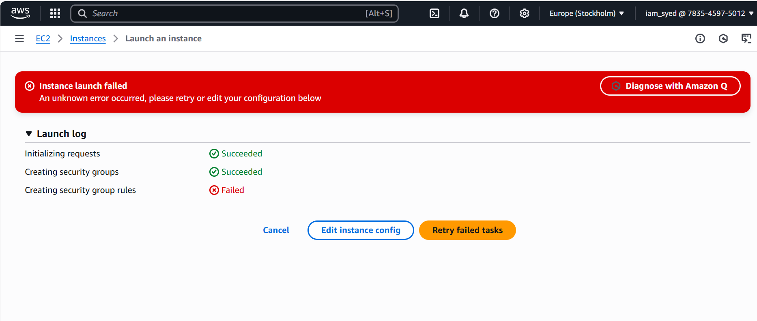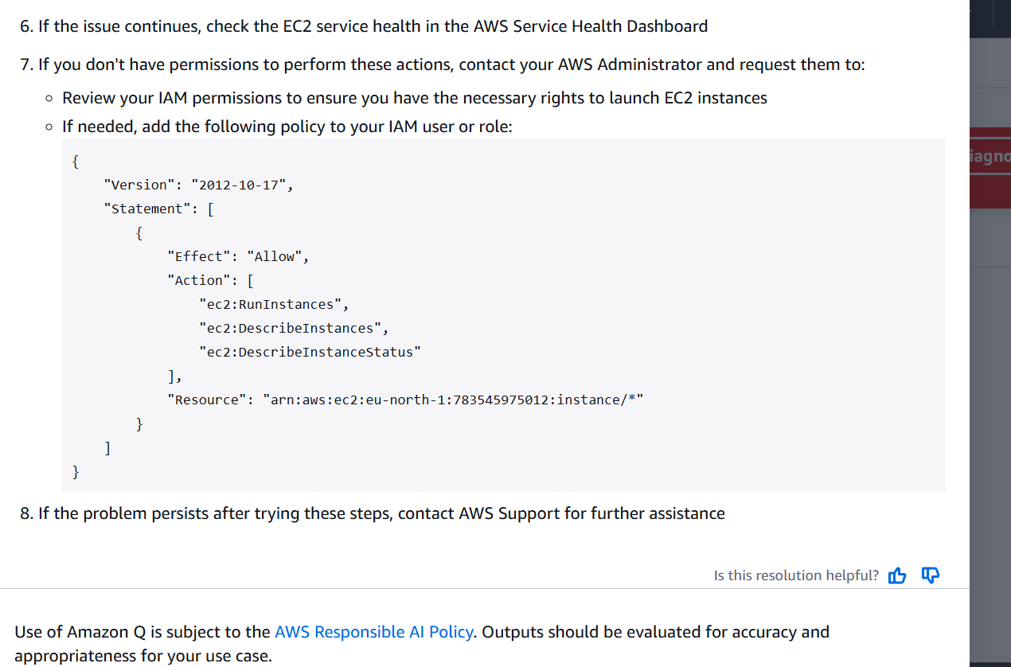

**6) We have two accounts Account A and Account B, Account A user should access s3 bucket in Account B. (Collaborate with team member and execute this Mostly asked in every interview)**

Prerequisites:

AWS accounts 2:

Account 1: Syedshakeel with AWS account ID : 783545975012

Account 2: Sripriya with AWS account ID : 750471539774

S3 Bucket created in Sripriya AWS account with S3-1105 name

In Account 1:

Create a IAM user with name crossaccount-s3

To this user create Inline policy and attach with IAM user created

Inline-Policy for IAM user

{  
 "Version": "2012-10-17",  
 "Statement": [  
 {  
 "Effect": "Allow",  
 "Action": [  
 "s3:GetObject",  
 "s3:ListBucket"  
 ],  
 "Resource": [  
 "arn:aws:s3:::s3-1105",  
 "arn:aws:s3:::s3-1105/*"  
 ]  
 }  
 ]  
}

Now Go to Account –2 of Sripirya S3 console

Select the bucket which you want to connect s3-1105

Go to Permissions and Edit Public access , enable it and block all public access

Go to bucket policy and Edit the policy, And generate new Policy using policy generator

For this we need iam user ARN number from Account –1

{  
 "Version": "2012-10-17",  
 "Statement": [  
 {  
 "Effect": "Allow",  
 "Principal": {  
 "AWS": " arn:aws:iam::783545975012:user/crossaccount-s3"  
 },  
 "Action": [  
 "s3:GetObject",  
 "s3:ListBucket"  
 ],  
 "Resource": [  
 "arn:aws:s3:::s3-1105",  
 "arn:aws:s3:::s3-1105/*"  
 ]  
 }  
 ]  
}  
Click Save Changes.

Once the Bucket policy is updated successfully

Go to AWS CLI and configure the IAM user using newly created ACCESS key and Secret Key credentials.

Aws configure –-profile crossaccount-s3

Once the configuration is done

Try to access the other account’s S3 bucket using

Aws s3 ls s3://s3-1105 --profile crossaccount-s3

You will see the objects available in the console successfully.

